Regatta Entry Packet
Head of the Brazos 2024

Baylor Club Crew
Waco, Texas

Important Information
EACH TEAM MUST HAVE A COACH SIGN AND TURN IN THE LAST PAGE OF THIS PACKET.

Overview
Baylor Crew's Head of the Brazos Regatta is back again for 2024! We will be running a 3,000-meter sprint again here on the Brazos River. Competitors will get to row from the iconic Waco Suspension Bridge near downtown, past the new Foster Pavilion, and near the rest of Baylor's athletic facilities including McLane Stadium. We will also have medals available to participants who place in each race.
Visiting crews should look forward to a competitive but friendly environment at this regatta. T-shirts will be available for sale and we are planning on having a food truck available. Additionally, spectators may have the chance to visit other fun attractions in Waco such as Magnolia Silos, the Cameron Park Zoo, and the Dr. Pepper Museum!
For lunch, we will have Vitek's BBQ on site from 11am-1pm.

Coaches and Coxswains Meeting
The coaches and coxswains meeting will be held at 6:50am on March 23rd inside the Baylor Boathouse. All coaches must attend and it is recommend that coxswains attend as well.

Launch and Recovery Docks
If both docks are available boats will be launched from the west dock and recovered at the east dock. In the less-than-ideal scenario where access to a dock is lost, launching boats will take priority and boats on the water shall hold across the river. A Baylor Crew member will staff each dock with a megaphone to facilitate timely launching and recovery to the best of their ability.
Important tip: Rowers should carry their boats from the bow and stern as our docks have some tight turns and steep ramps.

Venue Directions and Layout
The main venue area will be located at the back of the Ferrell Center parking lot. The address is 10 Daughtrey Ave Waco, TX 76706.
Below is an aerial view of our facilities for the regatta. The important thing to note is that shell trailers get priority parking closer to the boathouse. Spectator and athlete parking is set back further.
We recommend spectators park in the same parking lot (spots towards the boathouse are reserved for shell trailers) and walk up the river along the pathway. There is a grassy area just beyond the baseball field to set out blankets or chairs. Spectators who would like to watch from overhead can continue onwards towards the pedestrian bridge.

Venue Access
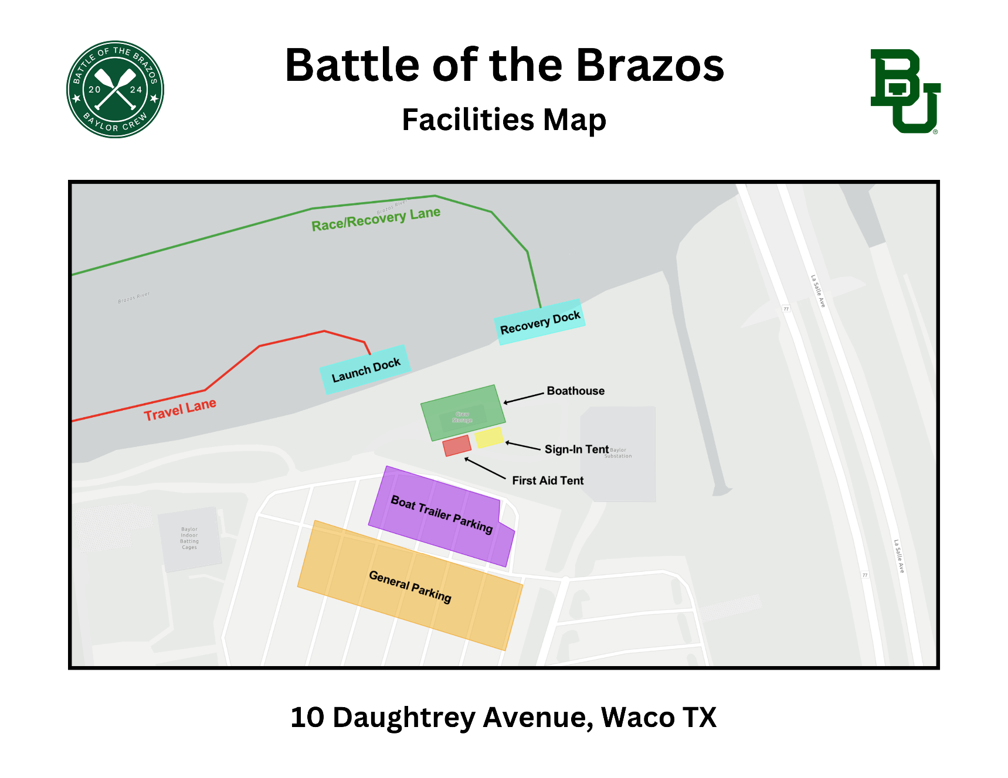

Inclement Weather Policy
Our Risk Management Chair will work together with our Executive and Coaching teams to monitor the regatta conditions and schedule during the event. Should it be determined that schedule changes are necessary, an announcement will be made at the race and via email.

Rules and Guidelines

Buoys
Boats must always be kept to the right (coxswain’s view) of the orange buoys during the event. In areas where there are no buoys, boats should keep to the left side of the river (coxswain’s view). Traffic patterns should be observed during practice as well as during races. Please see the racecourse map for further details.

Travel Lane
Once the buoyed course has been set crews proceeding downstream in the travel lane must proceed firmly. Boats may not stop to watch races and shall remain in single file unless there is clear room to pass. The travel lane areas are defined as 1) Left side of river (coxswain’s view) from the Baylor Boathouse to the starting chute near Cameron Park. Competitors are expected to prioritize safety and movement of the crews around them while in the travel lane. The primary warm-up area is in the designated warm-up queue just past the starting chute. Refer to the racecourse map for details. Competitors should anticipate limited space in the warm-up queue.

Right of Way
Boats racing have the right of way over all other boats. Boats not racing shall not proceed along any part of the course after the start of the first race of the day until the conclusion of the last race of the day.

Competitors Start Time
All competitors should be in the start line chute area within earshot of the start line no less than 5 minutes prior to the scheduled race start time.

Late Boats
Late arriving boats should not cross the line of buoys to jump into the starting sequence but should await instructions from the launch crew.

Warm-Up Traffic Pattern
All competitors warming up for the start must follow the warm-up traffic pattern except when otherwise directed by the launch crew. All competitors should be in the warm-up queue area five (5) minutes prior to the start of their race. Boats should assemble in the warm-up queue area in numerical order.

Equipment Failure
Prior to the start, if a competitor loses his/her bow marker or experiences equipment breakage prior to the start, he/she should notify the launch crew as soon as possible upon entering the warm-up area. There will be no guaranteed provision for breakage after the start.

Start Line Approach
Boats should merge into ONE single file line in numerical order as they enter the start chute, allowing an interval of 2-3 lengths (or as instructed by launch crew) of open water behind the preceding boat. Boats should maintain an interval of 2-3 lengths as they approach the start line. Crews or scullers that fail to follow the commands of launch crew may be penalized.

Coxswain on Board
Fours and eights must have their coxswain on board during the entire race. Failure to do so will result in disqualification.

Arch Violations Under Bridges
Going through the rightmost and leftmost pillars under the I-35 bridges, or going in between the pillars between the Suspension, Franklin, Old Railroad, and Railroad bridges (as described by the racecourse map) will result in a 60-second penalty in addition to any buoy violations incurred by doing so. Take note of the Traffic Patterns indicated on the racecourse map for all bridges along the racecourse.

Failure to Yield (Interference)
When a passing crew (the passer) closes to within one length of open water on the boat being overtaken, it is the responsibility of the slower crew to yield the line chosen by the Passer in a timely manner. The Yield should be completed by the time the overtaking boat has closed within ½ boat length.

Severe Collision
A passing crew (the passer) has the right to pass on the side of its choice if and when a safe pass can be accomplished. The passer must allow sufficient room for both their boat and the boat overtaken to stay safely within the racecourse. If a pass is attempted, the passer shall not press the right to overtake to the point of severe collision. The actual severe collision incident can be caused by either a passer or a passee. During a severe collision one or more of the following may occur:
(A) damage to a boat
(B) personal injury
(C) the boat being overtaken is forced either off the racecourse or into a bridge
(D) a rower is struck by the blades of another boat

Safety of Rowers
If one or more rowers are lost from a boat during the race, the affected crew should first ensure the safety or rescue of the rower(s). If the rower(s) is (are) safe, the crew may continue to the finish line.

Equipment and Safety Waiver
- All teams must have a copy of this page signed by their head coach.
- This waiver must be turned in on the day of the regatta.
- This waiver is SEPARATE from the participant waiver that ALL participants must sign.

Terms and Conditions
- By signing this waiver, the signee verifies to the best of their knowledge that:
  - All rowers of the signee’s team have been administered and have successfully passed a swim test in compliance with USRowing regulations.
  - All racing equipment (shells, oars, shoes, etc.) comply with industry standards and are in a safe and row-able condition.
- Additionally, the signee agrees on behalf of their team that:
  - Baylor University and Baylor Club Crew cannot be held liable for any equipment related losses, damage, or expenses which may incur as a result of participation in the regatta.
- Finally, the signee agrees that:
  - They understand the importance of ensuring the safety of all rowers and maintaining the integrity of their equipment.
  - They understand failure to adhere to safety protocols and guidelines may result in serious injury.

Signatures:

_________________________________
Name of Head Coach

_________________________________
Signature of Head Coach

_________________________________
Team Represented

_________________________________
Date of Signature

