Coaches,
Due to the 7:30 start time, we will not hold a formal coaches & coxswains meeting. Course Maps are posted below. Please make sure your coxswains understand that we will have numerous marshals from the cove to the edge of the racing course and at the start line to assist them with entry to the course.
Please share the following information with your coxswains
1. First call will be 45 minutes prior to race time, followed by a final call 30 minutes prior.
2. Boats must check in with Control Commission before each launch. Equipment safety rules will be enforced throughout the competition. We will employ spot checks as crews launch for proper bow ball and heel ties, so be certain that your equipment has been properly checked before you launch for each race. Any boat to be found not in compliance will not be allowed to launch. Racing will not be delayed for negligence to maintain equipment.
3. The course has lanes numbered 1-7, with 1-6 being the most frequently used lanes. Lane 7 is only used in 7 boat races. Lane 7 is closest to the beach. Note that Lane 7 may not have a buoy line on the starboard side of the lane.
4. Crews rowing to the start should launch from the cove and follow the single buoy line towards the start line. Coxswain’s should keep this buoy line just to their Port (left) side. They should ride the buoy line as if it was a racing lane, to ensure they don’t veer out into the open water where it will be difficult to marshal.
Crews have ample water to warm up in on the way to the start. Crews wishing more extensive warm up room may veer into the warmup area once they get to the end of the buoy line leading them out of the cove. While there will be numerous marshals on the course, crews are ultimately responsible on their own to be within the starting area on time such that they can be called in and locked onto the start platform 2 minutes prior to the start of their race. Officials may start any race at the 2 minute to start mark or below and crews should be prepared to race once locked on.
5. For the time trials, it is very important for crews to be aware of their bow numbers and to work to place themselves in the correct order and groupings on the way to the start and to follow the marshal’s instructions. While every attempt will be made to start events in bow number order, officials will place boats out of order where crews are late to the start area or where it is necessary to keep the regatta on time. Please CAREFULLY reviewing the map in the documents online regarding the time trial traffic pattern. Crews being overtaken (meaning the trailing crew is within 2 boat lengths and approaching) MUST yield to the inside lanes 1-6. Failure to yield typically results in a penalty of exclusion.
6. The breakage zone is considered the first hundred meters of the course. Please note that “jumped seats”, “catching a crab”, “loose bolts etc. on the boat” are NOT considered breakage. A Crew should not stop rowing or expect relief from the officials in these situations.
7. Crews who feel they were denied an opportunity of fairness during a race should indicate to officials that they wish to raise a concern. In most cases this must be done on the water before the crew’s returns to the dock. The official following a race will look to the crews for any concerns and the crew should indicate clearly that they wish to object at this point. Crews should be aware of the current 2017 Rules of racing and be familiar with what may and may not be protestable. Additionally, crews must be prepared to explain what remedy they wish to receive when raising an objection. Referees chasing each race will make a determination on the water whether they agree with the objecting crew or not. If a crew does not agree, they may raise a formal protest to the Chief Judge at the finish tent and should indicate to the chasing referee that they are doing so before leaving the water.
8. All boats wet-dock at the beach after racing. Boats are NOT permitted to relaunch from the beach for hot seating due to safety concerns.
If you or your coxswains have questions about the course or logistics, please ask when you check in or find the LOC and they will contact a referee if necessary.
Key information is posted on Regatta Central. The LOC has made every effort to ensure crews have the materials they need to participate in a safe and fair manner. Failure to have reviewed the regatta packet and other materials will not be a reason to protest an event. Lastly, USRA takes seriously Sportsmanship within the rowing community. Any instances of unsportsmanlike conduct will be dealt with quickly and may be addressed by any LOC or Race Official.

Travel to Start: Please follow the lane line going out of the cove, staying on the COURSE Side, but close to the line. This will get you to approximately 500 meters from the start. Continue to transit to the marshals and follow directions.
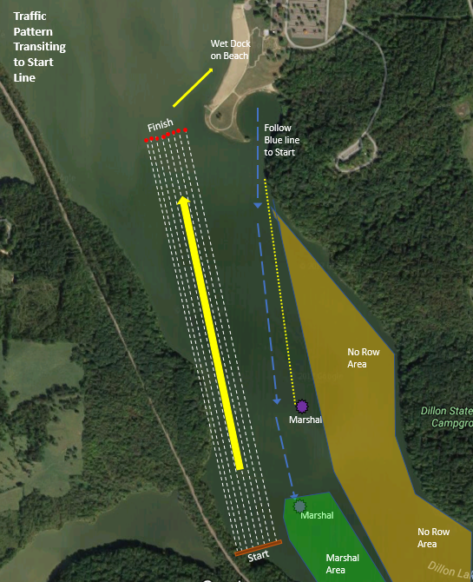

Head Racing/Time Trials Marshaling: Determination whether time trial starts, or head racing starts will be made once final number of entries is known and heat sheets are created.
Time Trials Setup: Boats preparing to enter the course should stack 2 or 3 wide (side by side) if wind allows, to help ensure they can enter the course more quickly. As the “row” in front of your row moves onto the course, the following rows should move up closer to the course. This will help ensure a continuous entry of boats onto the course.
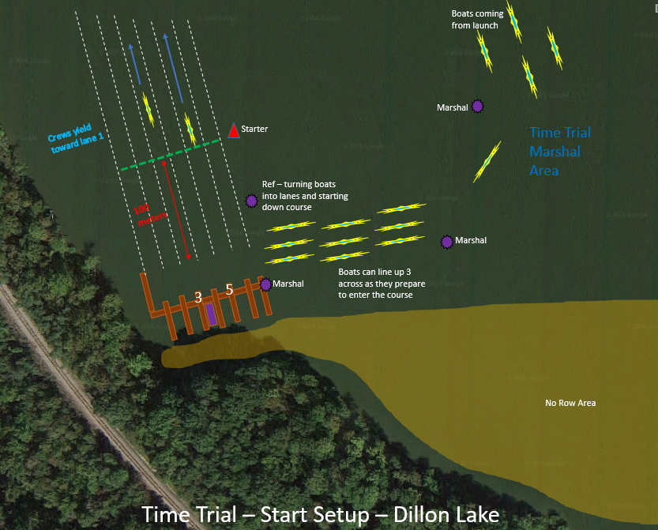

Head Race Setup: If winds are strong and schedule is too tight, we will move to a head race style start. Boats coming to start should follow marshal’s instructions. If boats become “stacked up” at the shoreline, they can position themselves 2 to 3 wide, to help facilitate getting boats efficiently to the start line. The marshal’s will “thin them down to 1 boat” as they get closer to the start. Boats should be at “full pressure’ as they approach the start dock. Crews will be sent off with roughly 20 seconds between boats.
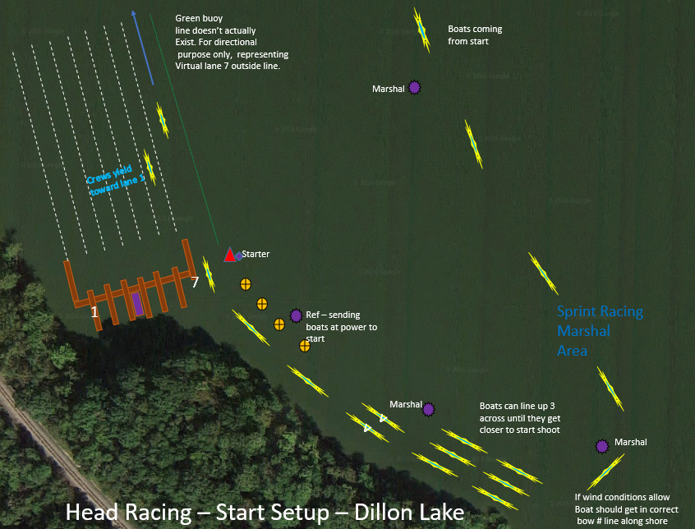

Sprint Racing: Heat waiting to enter course should enter as soon as called, with lane 1 entering first. Multiple lanes can enter the course at once with this configuration. If wind is high, marshals may change configuration. After waiting heat begins to enter the course, the following heat should move up to take their position off the edge of the course.
