Steerhead Regatta Head Race
September 14, 2013
Race Safety Packet

Contents:
Timetable
Regatta Overview and Procedures
Race Course
Race Schedule

Timetable
6:30 am – registration open
7:30 am – safety meeting for competitors
8:30 am – racing begins (All shells should be on the water by 8:10 am to ensure all boats are at the start for an 8:30 am start.)

Regatta Overview and Procedures
The 2013 Steerhead Regatta will be held on September 14, 2013 at the Fort Worth Rowing Club’s boathouse and dock on the Trinity River at Beach Street, Fort Worth, TX. The headrace will run approximately 3000 meters. The first event will begin at 8:30 am Saturday morning with all races completed by 2:00 pm. A meal will be provided for competitors between the hours of 11:30 am and 1:30 pm. The meal is included for unlimited racing entries. Meal tickets can be purchased for $5 for other participants.

Events are Masters Events with handicapped results.
Awards will be provided for 1st, 2nd, and 3rd place winners of each event.

Check –in: Registration will begin at 6:30 am at the Fort Worth Rowing Club boathouse. Registration will include verification of event entries, insurance waiver, and collection of any outstanding fees from participants.

Ample boat storage and trailer parking are available near the boathouse and dock for the day of rowing. We will arrange for overnight (Friday night) security of the equipment in the area. No security will be available for Saturday evening after conclusion of the event.

We will provide portable toilets. We will provide a limited amount of water and snacks. We suggest you bring plenty of additional water/snacks, lawn chairs, and a tent fly for shade – there is little shade near the dock, start and finish lines.

Safety: All equipment will be checked by the dockmaster acting as the control commission prior to launching. Bow balls and bow numbers are required equipment. All heel restraints should restrict movement to a maximum of 90° from the keel. Slings will be in position for crews needing to make last minute repairs. Please check equipment before approaching the dock to minimize delays in launching. All oars should be at the dock area before launching. Please place oars on the hill adjacent to the dock at the foot of the hill before the dam.
Two docks will be in position to allow for efficient launching and docking. Please follow the instructions of the dockmasters.

Regatta Meeting: The regatta meeting for all participants will be held at 7:30 am to discuss the course, hazards, and any other issues regarding the regatta.

Directions to the boathouse/dock: Traveling north on I-35W to Fort Worth, take the I-30 exit going east to Dallas. Exit I-30 at Beach Street (exit 16C). Take Beach Street going north (turn left on Beach Street). The Fort Worth Rowing Club boathouse parking area is just north of the Trinity River off of Beach Street.

Traveling south on I-35W to Fort Worth, take the I-30 exit going east to Dallas. Exit Beach Street (exit 16C). Take Beach Street going north (turn left on Beach Street). The Fort Worth Rowing Club boathouse parking area is just north of the Trinity River off of Beach Street.

From Dallas, take I-30 west to Fort Worth. Take the Beach Street exit (exit 16C) as you approach downtown Fort Worth. Exit I-30 at Beach Street (exit 16C). Take Beach Street going north (turn right on Beach Street). The Fort Worth Rowing Club boathouse parking area is just north of the Trinity River off of Beach Street.

For those coming from the south or east, do not take US287 into town. Instead get off at East Loop 820 and go north to I-30. Take I-30 to enter town from the east. Otherwise follow directions above from I-35W going north.

Club members will be at the boathouse until dusk on Friday evening, September 13, 2013 for clubs wishing to keep their trailers on the club grounds overnight. Security will be present overnight.

See map below.
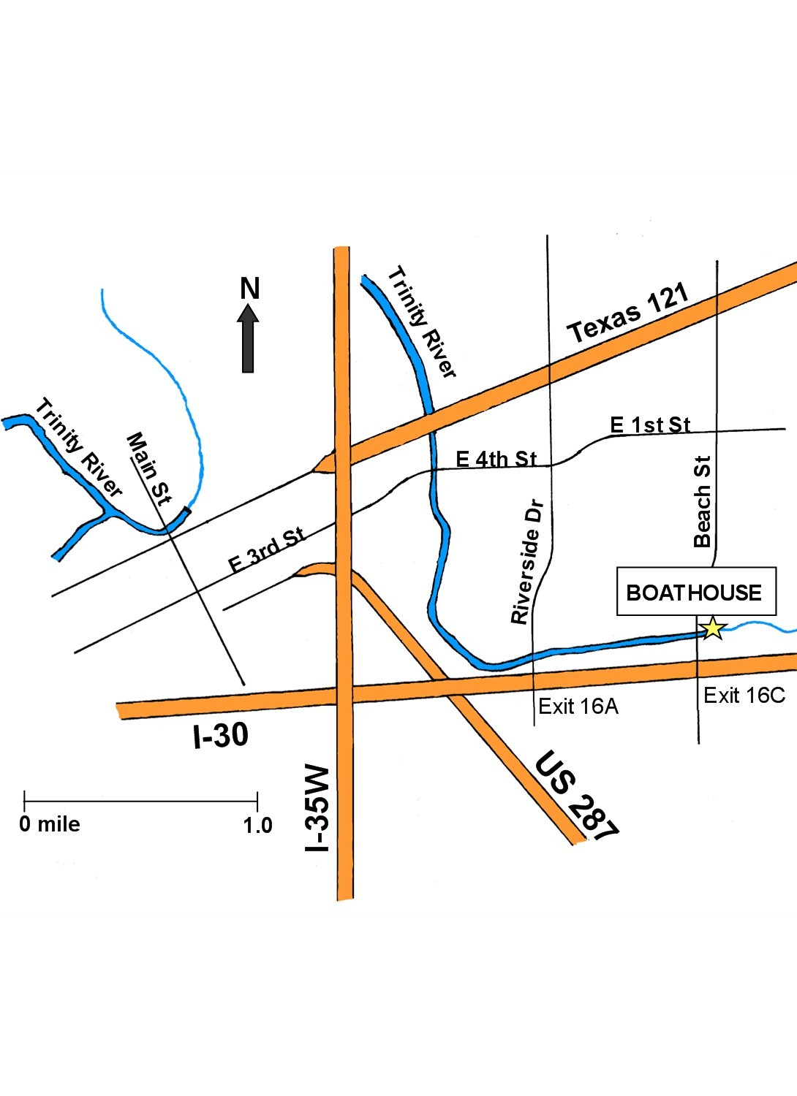

For additional directions, contacts, or other information about the Fort Worth Rowing Club, please refer to our website: www.fortworthrowing.com

Race Course
The race course is a 3000-meter course with all traffic in a common direction. Once racing has started for an event no boats will be allowed contra-flow to ensure the safety of all participants.
The course is detailed on the map above. The course starts just below the 4th Street Bridge and continues to just west of the Beach Street Bridge. Buoys will mark entrances to bridge passages. There will be no passing zones through all bridges with marshals stationed at these locations to alert participants of hazardous situations.
We will attempt to remove all debris and obstacles from the river. Please note however that we are on a river with continual flow. If hazards are found during racing, we will attempt to clear the course to eliminate or reduce possible damage to shells.
There are no penalty zones on the course. During the safety meeting we will alert all participants of shallow areas. Participants choosing to cut corners and enter such areas do so at their own risk.

Race Schedule

6:30 am – Registration opens

7:30 am – Safety meeting for all crews

8:10 am – all boats for first race on the water

8:30 am – 1. Mens Masters AA – D 1x
2. Mens Masters E – J 1x
3. Mens Masters Rec 1x
4. Womens Masters AA – D 2x
5. Womens Masters E – J 2x
Exception – OKC Mens 4x (Holliday)
Exception – TRC Mixed 4x (Nordskog)

9:30 am - 6. Mens Masters AA – D 2x
7. Mens Masters E – J 2x
8. Womens Masters AA – D 1x
9. Womens Masters Rec 1x
Exception - OKC Mixed Masters 2x (Burghart)
Exception – OKC Mens Masters4x (Sears)
Exception – Greater Houston Womens Masters 4x (Whitehead)

10:30 am - 10. Mixed Masters AA – J 2x
11. Womens Masters AA – J 4x
12. Womens Masters E – J 1x

11:30 am - 13. Mens Masters AA – J 4x
14. Mixed Masters AA – J 4x

12:30 am - 15. Mens Masters AA – J 2-
16. Womens Masters AA – J 2-
17. Mixed Masters AA – J 2-
Exception – TRC Mixed Masters 2x (Omer)
Exception – TRC Mixed Master 2x (Nordskog)

1:30 am - Awards Ceremony

11:30 am – 1:30 pm Lunch

