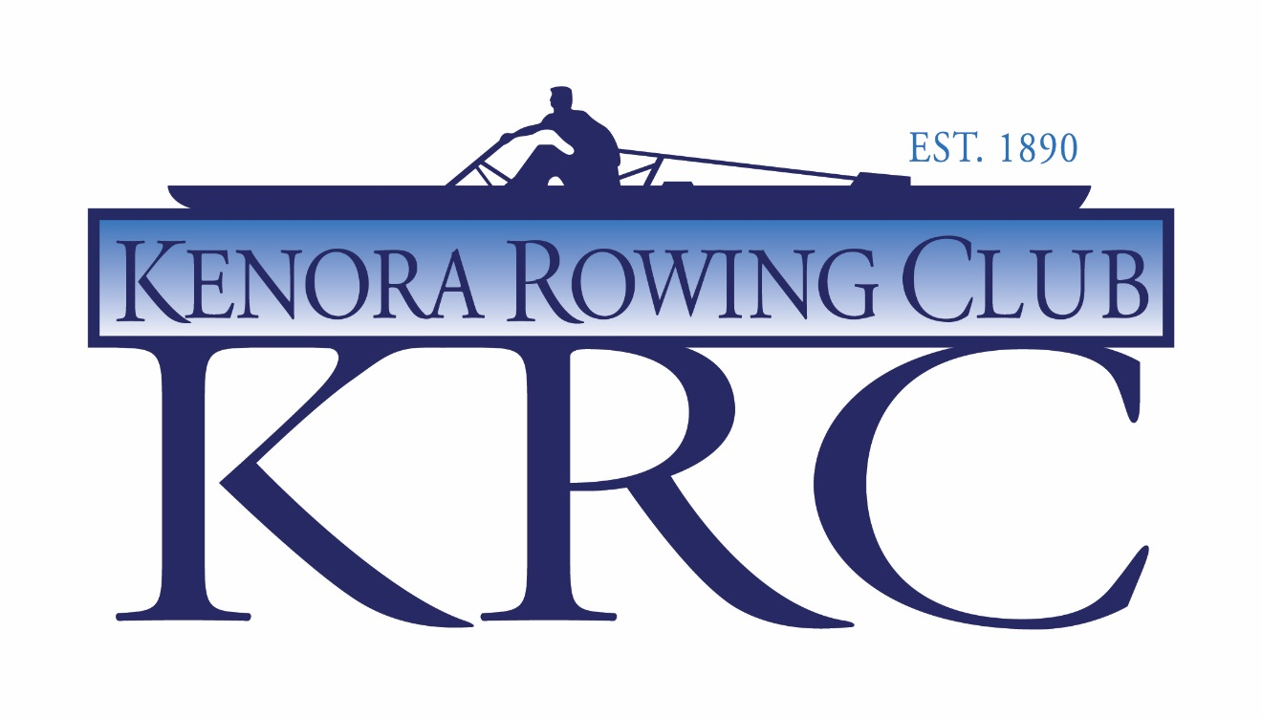
Tops and Bottoms Regatta 2018
Saturday, July 28, 2018
Rabbit Lake, Kenora, ON

You’re Invited! The Kenora Rowing Club invites you to join us for the 2017 Tops and Bottoms regatta on Rabbit Lake in Kenora. Tops & Bottoms will feature a 2000 metre course with stakeboat start. The Kenora Rowing Club site is situated in a park-like setting with Garrow Park and a public beach right next door, just 10 minutes from downtown Kenora. Tops and Bottoms is a great development regatta for new rowers. The focus of the event is masters(tops) and juniors(bottoms) , we will try to accommodate those between Junior and Master age categories travelling with their crew as we see fit. Please contact regatta co-chair Sue Straight at suestraight44@gmail.com if you have “odd aged” crews that you are bringing.

Regatta Site: The Kenora Rowing Club has worked hard to produce an exceptional venue for rowing regattas, including a buoyed course with stake-boat holders.

The Kenora Rowing Club is located 110 Birchwood Crescent on the south side of Rabbit Lake. There is room for boat storage on site, and the location is equipped with washrooms, First Aid, and a concession stand.

Accommodations: Kenora is a busy place in the summer, so book your accommodations as soon as possible. There are several hotels, resorts and camp grounds in the area. Camping at the club is available for one tent per club for boat security purposes. See www.stayinkenora.com for further information on hotels.

Parks
Anicinabe Park is located in Kenora just 10-15 minutes from the rowing venue, with camp sites, washrooms and showers, beach, and paddle board, kayak and boat rentals. Check out their website: http://www.anicinabepark.ca/

Rushing River Provincial Park is a beautiful park with camp sites, trails, and beaches, located 20-30 minutes east of Kenora and Rabbit Lake. Here is their website and on-line booking: http://www.ontarioparks.com/park/rushingriver

Resorts
The Kenora area has many resorts and lodges. Redden’s is on the east side of Kenora, about 20 minutes away http://www.reddenscamp.com/ Perch Bay Resort is on the west side of town about 20 minutes from the regatta site http://www.perchbay.com/

Entertainment: A BBQ will be held on site directly following the regatta. Tickets for non-rowers will be available for sale on site during the regatta.

Eligibility/Categories:

*Novice Rowers: Defined as any rower in their first year of rowing.
Junior B Rowers: U17 Born 2002 or later
Junior Rowers: U19 born 2000 or later
U23: Note: Will row in Junior events, but in own age category
Master Rowers: 21 +

Schedule of Events (attached): Heats (if necessary) will begin at 7:30am.
First call will be made at 7:00am. Finals will begin at 9:00am.

Awards: Awards will be given to the top finishers of each event at end of day.

Scratches: Scratches should be reported at the coaches meeting on Friday, July 27 at 6:00pm at the club house or by e-mail before the regatta rowkenora@gmail.com

Entries: Regatta Central www.regattacentral.com by July 21 @ 4 pm CST
Questions: E-mail Kenora Rowing Club at rowkenora@gmail.com

Entries received after this date will be accepted if they do not create a heat in the event.

Fees: $50.00 per competitor. All fees must be paid on line via Pelaton, Regatta Central or at KRC by one club cheque at the coaches meeting

Tops and Bottoms Regatta 2018

Order of Events

Number | Event
1 | Junior Mens 4+/-
2 | Junior Womens 8+
3 | Master Womens A-H 2X
4 | Master Mens A-H 1X
5 | Junior B Mens 2X
6 | Master Womens 4X
Break
7 | Junior Womens 2-
8 | Master Mens 4+/-
9 | Junior B Womens 2X
10 | Junior Mens 4X
11 | Master Womens A-H 1X
12 | Mixed Mash Dash 8+
Lunch Break
13 | Junior Womens 2X
14 | Master Mens 4X
15 | Junior Mens 8+
16 | Mixed Master 2X
17 | Master Womens 4+/-
18 | Junior Womens 4X
Break
19 | Junior Mens 1X
20 | Master Mens A-H 2X
21 | Junior Womens 1X
22 | Junior Mens 2-
23 | Junior Womens 4+/-
24 | Mixed Master 4X
25 | Junior Mens 2X
26 | Mixed Junior 2X

