Saturday & Sunday - April 27-28, 2019

Lake Stevens, Washington

2000 & 1000 Meter Racing
Youth, Masters, Novice and Open Events

8+ $100.00
4+, 4x $60.00
2-, 2x $40.00
1x $25.00
Out of State Clubs=50% off Saturday only
Register through Regatta Central

Hosted by:

The local community, the City of Lake Stevens and the Lake Stevens Rowing Club welcome you to the 2019 LSRC Spring Sprints Regatta on beautiful Lake Stevens just a short 5 miles east of Everett, on the weekend of, April 27-28, 2019..

General Information

Please review all information in this packet. Forward any questions to:
regattadirector@lakestevensrowing.org

The Venue
Lake Stevens is the largest lake in Snohomish County and located at the foot of and to the west of Mt. Pilchuck and the Cascade Mountain range. The community surrounding the lake is friendly and enthusiastically supports rowing on the lake. A 2000-meter course will be set for Youth/Open on Saturday while Masters/Open will race 1000-meter course on Sunday.

Directions
See driving map included in this packet.

Parking
In an attempt to reserve sufficient parking lot space for shells & stretchers, trailers are asked to park on the paved parking lots of North Cove Park adjacent to the launch dock. A parking attendant will be on hand to guide trailers to their assigned positions.

Vehicles car-topping boat(s) wishing to offload then move to street parking will be directed by parking lot attendants. Please do not park in the paved parking lots as this is the best area for trailers, stretchers, shell racks and shells.

Spectators arriving in standard passenger vehicles should use street parking and overflow parking in the middle school. Parking attendants will be on hand beginning at 5:00 am to provide maps and guidance (see parking map below).

IMPORTANT:
Please do not park in the shopping center parking lot; in the Post Office parking lot; in front of the apartment buildings adjacent to the Post Office; in the Library parking and North Cove Park.

Viewing Areas
City parks and public properties are all available for viewing. If you wish to watch from the finish, parking is available adjacent to the swim area (North Shore Drive) and finish line pier. However, please do not interfere with the Finish Line’s activities at the end of the pier.

Launch docks are reserved for launching and landing shells ONLY, no viewing is permitted. The city has limited occupancy to 50 people on the raised main dock in order to lessen the tendency for over loading.

Lawns and docks other than those mentioned are private property - please do not enter these areas.

Tents / Shelters
If you have plans to bring along portable shelters, please wait until 7:30 after the parking lot has been organized for trailers.

Restrooms
Restrooms are available at the Public Library, Senior Citizens Center and Portables on site.

Vendors
Vendors wishing to participate at the regatta must contact the Regatta Director no later than Friday, March 31,2018.

Local Weather
See (click here)

Overnight Trailer Parking
Friday night parking is available and will be assigned on a pre-assigned basis. You MUST contact the Regatta Director and make your needs known prior to April 25, 2019. Overnight security in the parking lots is provided as needed for Friday, and for shell parking areas Saturday night.

The City of Lake Stevens is undergoing a redevelopment and has removed some of the pavement near where some clubs have used North Cove Park to store trailers and stage equipment. Depending on weather leading up to the weekend, trailer parking may be directed to Main Street Parking, with equipment staging remaining in North Cove Park.

Again, it is important that you contact LSRC regarding your anticipated trailer arrival time and intended period of stay prior to coming to town.

First Aid
In the event of an emergency report to the Regatta Headquarters at the entrance to the launch dock or talk to the nearest regatta staff person with a radio. For more serious emergencies call 911. We are located in Lake Stevens North Cove Park. Then get word to regatta headquarters.

Emergency medical support will be provided by the Lake Stevens EMS located 1000 meters from Regatta Headquarters. A basic first aid kit is available at Regatta Headquarters.

Regatta Staff
Licensed officials have volunteered their time and talents to manage on the water activities. The Lake Stevens Emergency Services may be patrolling the race course to ensure the safety of all competitors. Other volunteers are local residents who have expressed an interest in our sport. Your courtesy is appreciated.

Regatta Headquarters is situated in the parking area near the entrance to the recovery and launch docks. Please do not hesitate to stop by with any questions you may have.
Regatta Information
General Timeline
4/21/19 – entry deadline
4/25/19– final schedule posted
Each race day
SATURDAY
8:00 am Coach & Coxswain Meeting
8:30 am First boats launch
9:00 am First race of the day

SUNDAY
7:00 am Coach & Coxswain Meeting
7:30 am First boats launch
8:00 am First race of the day

Entry Fees
8+ $100.00
4+, 4x $60.00
2-, 2x $40.00
1x $25.00
50% off for all out of State Clubs-Saturday only
Enter at Regatta Central between March 21st and the deadline, April 21, 2019. A preliminary schedule of events is also there.

Competitors
The 2019 LSRC Spring Sprints is a USRowing Registered Regatta and as such, participants must be active members of clubs with current USRA or CARA organizational membership. Those entering as “Independent” must be individual members of USRowing or CARA.

All clubs/competitors must have valid waivers by April 21, 2019.

Classifications
Youth: See USRowing rules.
Open: This category is open to anyone with racing skills.
Masters: 21 years of age or older.
AA Masters will not receive the benefit of an adjusted time.
Novice (Youth): Anyone who has not raced before 6/30/2018.
Novice (Masters): Anyone who has not raced before 6/30/2018.
Age in Years is the age of the competitor on 12/31/2019

Varsity / 2nd Varsity Events
To compete in the 2V level of an event a club must have an entry in the 1V level of the same event. For example, a club must enter the Youth Mens Varsity 1X in order to gain entry into the Youth Mens 2V 1X event. Limited exceptions may be granted in advance by the Regatta Director.

Weigh Ins
Weigh-ins will utilize the honor system.

Heats & Finals
All events will be Finals. Any event with more than 6 entries will use Timed Finals.

Masters Schedule
After entries close, the Regatta Director will seek to equitably divide all masters entries into age categories dependent upon the number of entries in each event.

Coach Check In
On the day of the regatta, before the C&C Meeting each club must check in at Regatta Headquarters to receive any updates and to provide your coaches phone number to receive text alerts.

Boats & Slings
The large paved parking lot is reserved for shell staging. Shell trailers will be parked in this area where trailers are expected to be used as additional racks space.

Regatta Meetings
The Coaches’ and Coxswains’ Meeting will be held outside Regatta Headquarters near the launch dock at 8:00 am Saturday and 7:00am. Sunday. Traffic patterns and race course will be reviewed, questions answered about regatta rules, and any changes to the final schedule made. All teams are well advised to have a representative at the meeting.

Safety Requirements
All boats must have bow balls and quick release shoes or clogs in working order. Shells out of compliance will not be allowed to launch.

Safety Checks at Launch
LSRC will issue bow numbers to ALL competitors. Each shell must pass a safety inspection in the Control Commission area prior to being issued a bow number and launch directions. Failure to complete the safety inspection will delay your launch time until you have been approved.
Failure to check in may also result in a crew’s race commencing without them.

Awards
First place medals will be awarded to crews in each event. Second and third place ribbons will be awarded to crews in each event as well and will be available for collection at Regatta HQ after official times have been posted. Results will be on www.regattacentral.com, HereNow and www.LakeStevensRowing.org.
Please reference HereNow for the most up to date results.

Launching / Landing
Dock Masters will be stationed on the launch and landing dock. Please communicate any launching issues with Regatta Staff as you approach the equipment safety check area. Regatta Headquarters will be in direct contact with officials on the water. We are set up to launch / land every two minutes. You are well advised to organize yourselves accordingly. You will not necessarily be called to launch.
Please allow enough extra time for an equipment safety check after which you will be directed onto the south side of the main launch dock complex.

Crews ready to launch are advised to make arrangements to have oars carried to the dock with the shell, a bow ball securely in place, gates open on oar locks, all heel ties in working order and regulation compliant. Your equipment will be checked and a bow number affixed as you move onto the launch dock bow first.

IMPORTANT COACHES:
Please do NOT enter the Recovery Launch Dock until your crew has arrived at the dock. If the recovery dock is required for launches due to congestion at the Launch Dock Do NOT remain on the dock after your crew has departed. Failure to comply with direction by the Regatta Director or Dock Master will risk being escorted from the area.

Hot Seating
To facilitate on-time racing all coaches must come prepared to the Coaches & Cox’n’s meeting prepared to indicate which crews/boats will be hot-seated. Regatta officials will endeavor to facilitate rapid hot-seating.
A hot seat of crew members into the same shell may be asked to do so without removing the shell from the water. Crews involved in a hot seat requiring a change of shells are expected to have the shell inspected and waiting on slings ready for rapid launching. Coaches are well advised to have sufficient team members available to handle incoming equipment so hot-seating crews can move directly from the previous race’s shell on the Recovery Dock to the awaiting shell at the Launch Dock.

Drone Policy
If you intend to fly a drone you must obtain pre-approval from the Regatta Director and Chief Referee by 9:00am the day of the regatta. You must follow the USRowing drone policy found here-
USRowing Drone Policy
Finally, all drone operators must sign a Hold Harmless Agreement. Copies at Regatta HQ or here-
Hold Harmless Agreement

In accordance with
USRowing Rules of Racing (2019)

Note Changes:
4-104.1 (c) Youth: A Youth is a Competitor who in the current calendar year does not attain the age of 19, or who is and has been continuously enrolled in secondary school as a full-time student seeking a diploma. A Competitor thus ceases to be a Youth after December 31 of the year of his or her 18th birthday, or of the year in which he or she completes the 12th grade of secondary school, having been a full-time student, whichever is later.

Specific Rules Waived
10-310, Minimum Weight of Boats;
4-106, Weighing of Competitors.

Rules Waived-w/ LOC Permission
4-103(h), Eligibility to Compete in Events

Traffic Pattern
The traffic pattern is shown on the accompanying map. Shells moving to the start line shall move in single file along the eastern side of the course until they reach the warm-up area. Each day the warm up areas will be reset adjacent to the start line for the day. Saturday the 2000m mark (Youth/Open) and Sunday the 1000m mark (Masters/Open). NOTE: Large marker buoys will set the western most limit of the warm up area.

Crews MUST move in a clockwise direction around the warm-up buoys. When called forward to the start line crews will do so as they are moving in a westerly direction.

The Start
Starts will be floating starts unless stake boats are available.

The Finish
The finish is set off the public swim dock on N. Lakeshore Drive. Yellow buoys indicate a very close approximation of the finish line. The exact line is set by compass bearing made by the Chief Referee from the Finish Line Dock. Be sure to identify the various marker buoys on your way to the start. Clear the finish area as soon as possible and move directly back to the Recovery Dock.

Protests
Normal USRowing protest procedures and rules will be applied.

Race Schedule
The final race schedule will be available on Regatta Central , no later than midnight Thursday, April 25, 2019.

N

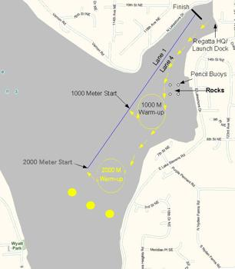

Driving Directions

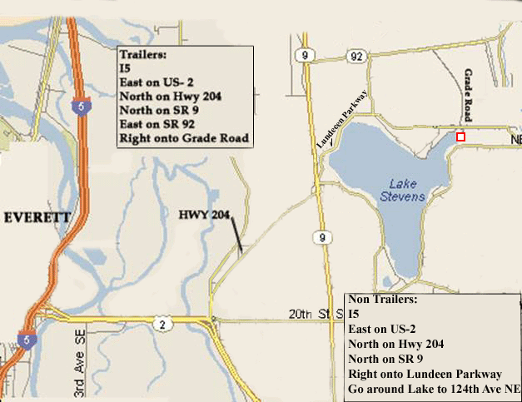

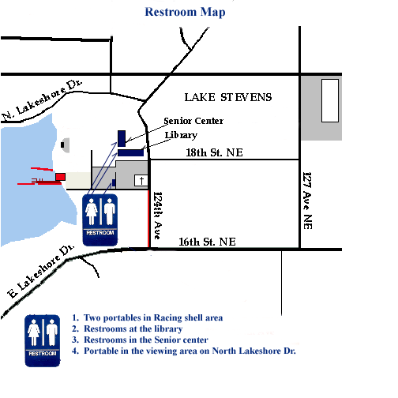

Friends and Sponsors of Lake Stevens Rowing Club & 2018 Spring Sprints Regatta:

