Massachusetts Public School Rowing Association
14th Annual Fall Championship
2013 Regatta Packet


Hosted By: MPSRA in association with
Shrewsbury High School Crew &
Worcester Public Schools Crew

Venue: Lake Quinsigamond
Worcester, MA

Distance: 2 miles – sculling/novice
2.6 miles - varsity

CRITICAL NOTICES

DUE TO BRIDGE CONSTRUCTION, THIS IS A NEW COURSE FOR 2013

The regatta will follow USRA’s Rules of Rowing. Please make sure your crews understand this information. Crews who are unsafe or arrive late to the line will not be allowed to race.

Late Arrivals:
- Crews arriving late for their start but before the last crew in their event will be allowed to start after the last starting crew with the addition of a 10 second lateness penalty.
- Crews arriving late for their start and after the last crew in the event has started will not be allowed to race.

In response to problems with unqualified novice crews, we have had to institute the following rule; if a novice boat is disqualified for safety reasons, that boat's entire novice squad (boys and girls) will be disqualified from the regatta and will not compete in any remaining races.

All teams currently in possession of trophies MUST return trophies prior to the start of racing.

GENERAL INSTRUCTIONS

- Race Day Registration – Registration is at regatta headquarters at the boathouse at Regatta Point. All teams must register between 7:00AM and 8:30AM. Clubs missing waivers, rosters or regatta fees will not be allowed to register.

- Coaches & Coxswain's Meeting – Will be held at 8:30AM and is required for all. Attendance will be taken and teams who do not attend will not be allowed to race.

- Important features for your equipment:
  - All shells must have a bow ball.
  - All shells must have heel tie-downs that do not allow the rower to raise heels more than 3” from the footboard.
  - If any of the conditions are not met you will not be allowed to launch.

- Bow Markers: The MPSRA will provide bow markers for the boat and back numbers for the bowman, which must be returned to the dock-master before leaving the landing dock.

- Order of Event Cancellation: If an event is canceled both the boys and girls events will be canceled together, in each category smaller boats will be canceled first. The Chief Referee will make the call to cancel.
      - Sculling
      - Novice 4
      - Novice 8
      - Varsity 4
      - Varsity 8

ELIGIBILITY

Program Eligibility:
Entry into the 2013 MPSRA Championship is open to all MPSRA Full and Provisional Participant Programs currently in season. Please see the Procedural Rules posted on the MPSRA website (mpsra.org) for information on what constitutes a Participant Program.

Athlete Eligibility:
Please see Procedural Rules for detailed Athlete Eligibility Information

Novice Rowers – As stated in the MPSRA Procedural Rules, to row as a novice, a competitor must be no older than a freshman or in his/her first year of rowing.

Double Entries – Double entries are not allowed between two sweep events. Double entries of athletes between a sweeps and a sculling event is allowed. Exceptions to this rule may be made at the discretion of the Regatta Director.

Sculling Entries – Sculling events may be entered by public school crews not affiliated with an MPSRA Participant Program subject to the conditions specified in the Procedural Rules.

INSTRUCTIONS TO COACHES & COXSWAINS/BOWMEN

- Compliance with the USRowing Rules of Rowing – The regatta will comply with all US Rowing Rules of Rowing. Please make sure your crews understand this information.

- Cancellation/Delay – Regatta officials may call for a delay or cancellation of racing due to conditions endangering the safety of rowers, staff or spectators. Final decision for delay or cancellation will be made by the Chief Referee. Following a decision to delay racing, the Regatta Coordinator will announce a revised racing schedule with compressed racing centers. Event cancellation will begin when all remaining events cannot be held by the end of the day and will follow the order posted with the schedule.

- Mandatory Coaches and Coxswains/Bowman Meeting
  - Time: 8:30AM
  - Location: in front of the boathouse at Regatta Point
  - The Course, Bridge and Course crossing will be reviewed in detail in this meeting

- Warm-ups/Launching: We will stick to the schedule. There will NOT be exceptions for any crew hot-seating boats. All schools should note that a crew with one warning for a traffic violation risks disqualification if that same crew receives a second warning for some other infraction. Also, please note the following points:
  - Crews should plan to allow 45 minutes to get to the starting line. Crews will not be allowed to launch more than 60 minutes before their race time.
  - Crews shall cross the course ONLY on a regatta marshal command.
  - Crews warming up must follow directions of the regatta marshals.
  - Crews should keep the line of buoys to the starboard side of the boat at all times.
  - The second arch from the Shrewsbury shore is the travel lane for crews warming up. The open arch is partially obstructed by the continuing construction.

- Approaching the Start: Crews and coxswains will be marshaled in the area below the start. This will be a different location for varsity races than for novice/sculling races. Coxswains must familiarize themselves with the course map on the final page of this document before launching. The line on the right marks the warm-up course; the line on the left marks the race course (arrows are reversed). Novice and sculling races will begin at the Narrows. Varsity races will begin at the spot marked “Starting Line” on the map. All races will end at the DRC.

- On the way to the start, crews must keep buoys on their starboard side, staying single file on the Shrewsbury side of the lake.

- Races will be organized upstream of the start in the 10 minutes before race time. Coxswains must know how to maneuver their boats with both rowing and backing strokes and must follow all directions of the start marshals. Upon arrival in the starting area, coxswains should find the two crews starting directly ahead of them and should remain near these crews as the start time approaches.

- The Start will be Called by the Start Referee: The referee will be on a pontoon boat. Crews are expected to follow all directions and to be prepared to cross the start line at full pressure.

- Equipment Breakage: All crews and scullers are responsible for a complete check of equipment prior to leaving for the start.

- Race Course: The course for novice and sculling events will start at the Narrows and run to the DRC. The course for varsity races will start on the Worcester side of the large island (marked “Starting Line” on the map) and will follow the course pictured there, passing to the left of “fire island” and straight up through the Narrows. Note that this is opposite from previous years. On the map included below, direction is reversed. All crews will race through The 2nd arch from the Worcester shore ending at the DRC. THE SECOND ARCH IS THE OPEN ARCH FOR RACING. Keep all centerline bouys to starboard, staying on the Worcester side of the Lake

- Race Course Obstructions: Coxswains should keep clear of the public beach and the pump house areas. Both areas will be marked, however coxwains should use care wherever they are on the lake.

- The Finish: Will be marked by bouys. The finish line is the DRC meeting building. After finishing, continue rowing until reaching the I-290 bridge.

- Landing Shells: Should stop north of the landing docks and await marshalls instructions. Crews should not drift down to the beach. Crews shall cross the racecourse on the marshalls instuctions only.

- No Passing Zone: THERE IS NO PASSING IN THE NARROWS
- No Passing Zone: THERE IS NO PASSING WITHIN 300 FEET OF THE Rt. 9 BRIDGE

- Giving Way: A crew being passed must yield to the overtaking crew. Failure to do so will incur a penalty.

- Penalties:
  - A 10 second penalty will be applied for being late to the start
  - A 20 second penalty will be applied for failure to give way or bouy violations
  - A 40 second penalty will be applied for a poor cross (leaving or returning to the dock)
  - A 2 minute penalty will be applied for a pass or attempted pass in the narrows or near the Rt. 9 Bridge
  - If, in the view of the chief referee, a crew makes a dangerous pass, including or not including contact with another crew, that crew shall be excluded.

- Protests: In the event of a Protest, it must be made on the water at the end of the race and then presented in writing to the chief referee or regatta office attn: chief referee within one hour of the completion of the race in question along with a $25 fee. The fee will be returned if the protest is ruled in your favor.

- Voiding: There shall be no urination in the lake; a violation results in immediate disqualification from the regatta.

- Medals: Medals will be awarded as follows:
  - 2 or 3 boats = 1 medal
  - 4 boats = 2 medals
  - 5+ boats = 3 medals
  - This does not include scratched entries – the number of medals awarded depends on the number of boats physically present at the start for a particular race.

VENUE INFORMATION

Regatta Office: Located at the Regatta Point Boathouse. Note – spectators are not allowed in the regatta office – coaches and authorized volunteers only!

Spectators: There is significant space available for spectators at the venue. We request that spectators avoid the launching area whenever possible to avoid congestion. Spectators will not be allowed on the docks/beach launch area. The admission fee is $5/person (athletes not included).

Bathroom Facilities: There are restrooms at the boathouse, and there will be porta-potties available as well.

Results: Results will be posted on boards at the boathouse. Complete results will be available after the regatta at www.row2k.com.

Parking: THERE IS NO PARKING ALONG N. LAKE AVE. DUE TO ROAD CONSTRUCTION. Parking in the lot will be available for trailers for free and for team vehicles for $10 per van/car. Spectators must park at UMass Medical (be prepared for a $5-$10 parking fee). Buses only may park along the road. Shell trailers will be instructed how to park on arrival. All trailers should be parked without extraneous space in between.

First Aid Location: There will be EMTs at the boathouse.

Shell Storage: There is no rack space available at this venue. All crews should bring their own blocks/slings.

Garbage Removal: Please deposit all trash in closed garbage bags.

BRIDGE IMAGES

Looking South, from regatta point, towards the start:

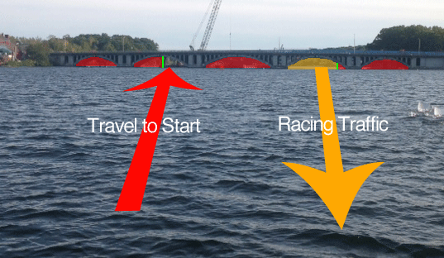

Looking north, as if you were coming up the course:
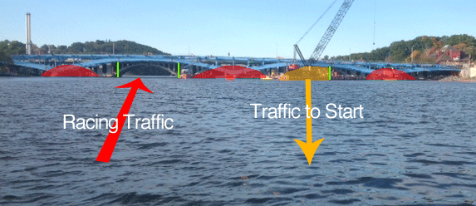

COURSE MAP
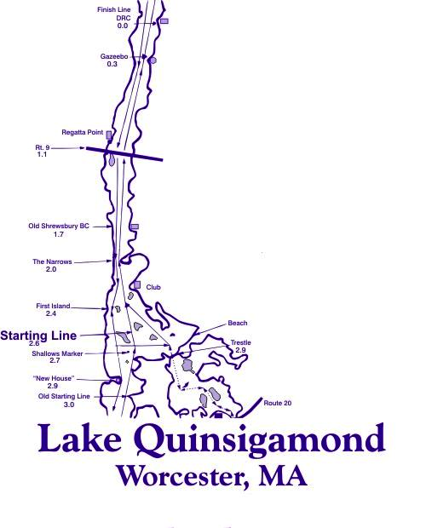

*Please note for 2013, the course is reversed. Crews will race up the left, Worcester, side.

