Regatta Information

Regatta Committee:

Brooks Reinhard, Regatta Director
John Musial, Chief Referee
Kelsey Reinhard, Regatta committee
Anthony Neczypor, Regatta committee
Heather Brooks, Regatta committee
Jamie Stack, Regatta committee

The first annual Steve Neczypor Memorial Regatta will be held Saturday, April 5, 2014 on the Cooper River in Camden, NJ.

The regatta is open to Junior Club teams and High School teams.

Please find enclosed:

- Regatta information
- List of events
- Awards
- Registration, waivers and entry fee information
- Rules and regulations
- Venue information
- Directions and parking
- Volunteer information
- Spectator information
- Advertisement book

If you need more detailed information, please contact Brooks Reinhard at mrneczregatta@gmail.com.

Steve Neczypor Memorial Regatta: www.mrneczregatta.com

Regatta Information

Date: | Saturday, April 5, 2014
Location: | Cooper River, Camden County, NJ
Race Distance: | 2000 m
Start time: | Heats will start at 9 am for Varsity events. Varsity finals will start when heats are completed.
Coach/Coxn meeting: | 7:45 am at boat staging area
Weigh Ins | There are no weigh ins for lightweights or coxswains. You are on your honor to correctly boat your lightweights.

Registration Important information.

  - This is a USRowing Registered Regatta. All clubs or are required to be members of USRowing in order to participate.

  - Registration is online at Regatta Central www.regattacentral.com.

  - JV and Novice events will be capped at 18 entries per event. Oversubscribed events will be wait listed.

  - For JV and Novice events there is a limit of 2 entries per team for each event.

  - Teams will be responsible for the entry fee and a $75 scratch fee for scratches made after the entry deadline.

Waivers

Submit USRowing waiver through Regatta Central with your registration. Or mail waivers to Steve Neczypor Memorial Regatta, 7050 North Park Drive, Pennsauken, NJ 08109

Refunds

There will be no refunds if the regatta is cancelled due to inclement weather.

Race Schedule

First race is at 9:00 am.

There will be heats for varsity events, prior to the start of final events. Varsity finals will start after completion of event 34.

For 7 boat Varsity races, the progression will be 3 advance from the heat with 4 boats, and 2 advance from the heat with 3 boats.

For JV and Novice events, each race will be run as a final.

An official schedule will be released at the close of registration.

1 |  | Womens Ltwt Varsity 2x | 18 | Mens Varsity 8+
2 |  | Mens Ltwt Varsity 2x | 19 | Womens Varsity 4x
3 |  | Womens Novice 8+ | 20 | Mens Varsity 4x
4 |  | Mens Novice 8+ | 21 | Womens Novice 2x
5 |  | Womens Ltwt Varsity 4+ | 22 | Mens Novice 2x
6 |  | Mens Ltwt Varsity 4+ | 23 | Womens JV/2nd Var. 1x
7 |  | Womens Varsity 1x | 24 | Mens JV/2nd Var. 1x
8 |  | Mens Varsity 1x | 25 | Womens JV/2nd Var. 4+
9 |  | Womens Novice 4+ | 26 | Mens JV/2nd Var. 4+
10 |  | Mens Novice 4+ | 27 | Womens Ltwt 8+
11 |  | Womens Varsity 4+ | 28 | Mens Ltwt 8+
12 |  | Mens Varsity 4+ | 29 | Womens JV/2nd Var. 2x
13 |  | Womens Varsity 2x | 30 | Mens JV/2nd Var. 2x
14 |  | Mens Varsity 2x | 31 | Womens JV/2nd Var. 8+
15 |  | Womens Novice 4x | 32 | Mens JV/2nd Var. 8+
16 |  | Mens Novice 4x | 33 | Womens JV/2nd Var. 4x
17 |  | Womens Varsity 8+ | 34 | Mens JV/2nd Var. 4x

The schedule is tentative and subject to change.

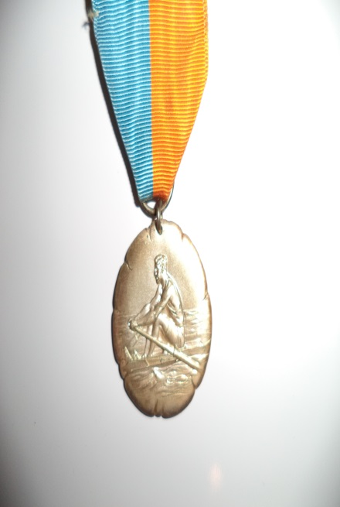
Awards

Varsity Events

1st, 2nd, and 3rd place medals will be awarded. Trophies
will be awarded for all Sponsored events.

JV and Novice Events

A 1st place medal will be awarded for
each race. There will not be heats. Each race will
be rowed as a straight final.

Venue Information

Parking

Please follow the instructions of those directing the parking of trailers. We hope to have the trailers in line one behind the other so there are aisles for crews to walk to and from the trailers and docks easily. The first trailers in should back up to the walkway and continue to pull in next to each other going around the perimeter of staging area. Once we bring the trailers all the way around we will back trailers into place in front of those on the perimeter. Please leave about 12 feet side to side and enough room back to front to get your boats out of the center racks. Once your trailer is parked the truck must move out onto the street in the designated parking area. Please be courteous when parking as we need to get quite a few trailers into this area. Allow room for neighbors.

The street will not be closed. Team vehicles, buses and vans, plus tow vehicles with passes will park in the area with the no parking signs in the finish line and staging areas. We will be handing out parking passes as you bring your trailer into the staging area. All parents will park in the street and parking lots going up the course from the finish line area.

The race course
Cooper River Park's Olympic-distance 2000-meter straightaway has drawn praise from international rowing experts who say its sheltered, narrow course provides ideal rowing conditions. Cooper River Park has hosted numerous major rowing events, including the Olympic trials and the Intercollegiate Rowing Association championships.
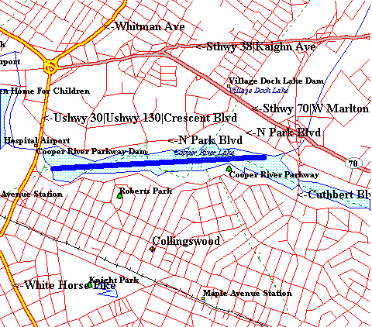

- Six lane buoyed source
- Stake boats
- Spacious viewing area
- Plenty of space for teams

Rules and Regulations
In addition to the rules of USRowing, the following rules will apply. Complete rules of USRowing are available in PDF form on their website www.usrowing.org.
Regatta rules
- Novice boats may not race in Varsity events.
- Any athlete who is a postgraduate or in his 5th year of high school cannot participate.
- Any student who turns 19 by September 1 of the school year cannot participate.
- There will be no refunds unless the event is cancelled for low entries. Coaches will be notified of event scratches no less than two days before the regatta. There must be two crews entered or the event will be canceled.
- There will be no registration day of the regatta. Any missing paperwork or payments must be submitted to the finish line trailer.
- There will be a 20-second equipment breakage rule.
- All questions of eligibility, qualification, and interpretation of the rules will be referred to the Regatta Committee, whose decisions will be final. The USRowing Rule Book is the ultimate source for all rulings.
- The dock master must be notified of all hot-seat boats before the boat goes out for its first race.
- The event schedule is subject to change depending on the entries received.
- All athletes and coaches are reminded that sportsmanlike conduct is expected.

Racing Details
- The course will be fully buoyed. The start is on stake boats. Novices will be expected to connect to stake boats in a timely manner. Coaches please practice stake boats.
- All boats shall provide their own lane #’s and must be equipped with a bow ball and foot release straps. All boats will be checked.
- Launch when called: Have someone carry oars to the dock for your crew; Tie in on the water; 90 seconds on the dock. Follow buoys away from the dock.
- Row up to the start staying outside lane 1. Do NOT stop on the finish line on your way up. Try to stop if possible when a race in coming down but do not make yourself late to the start.

- There will be a marshaling area at the starting line. Remain in the marshaling area until called to your lane.

- Boats will enter the course in descending order starting with lane 6 going across first, then lane 5, etc...
- Be ready to start at any moment. With a tight schedule the starter can not and will not wait for boats that are not following instructions or are not getting into the stake boats in a timely manner. Count down starts will be used at the starter’s discretion.

- Races will not be held up for hot seating or crews not in the marshaling area prior to your event being called to the line.

- The breakage zone is clearly marked, if you break equipment in the zone stop, raise your hand and notify the officials immediately. Jumped slides, crabs, and problems with the cox box do NOT count as breakage.

- After you cross the finish line stop, follow the buoy line steering your boat toward starboard. Steer well clear of boats launching and proceed to the landing dock.
- Coaches have someone on the landing dock to get your crews oars off the Dock quickly. Again no more than 90 seconds on the dock.

- If after the race you wish to protest you must sit at the finish line and raise your hand. An official will come over and listen to your protest. They will either make a decision there or tell you to write a formal protest and give it to the Chief Referee. If they give you a decision on the water but you still feel that is not acceptable you can appeal to the Chief Referee in writing.

Directions

Camden County Boathouse, 7050 N. Park Dr., Pennsauken, NJ 08109.

From the West:
Pennsylvania Turnpike east to the Valley Forge exit. At Valley Forge take I-76 (Schuylkill Expressway) east to Philadelphia. Stay to the left after passing the Girard Avenue Exit. Exit at I-676 (Vine Street Expressway). Follow signs for Ben Franklin Bridge. Go straight ahead after the tollbooth to Admiral Wilson Blvd/Route 30. Do not bear right onto I-676.

Go about one mile and then take the right branch at top of overpass onto Route 130 South. Immediately get in the right lane, and take the jug handle for North Park Drive. Follow North Park Drive about 1.5 miles and trailer only parking is to the right, just before you come to Cuthbert.

From North or South:
Exit New Jersey Turnpike at Exit 4. Go right onto NJ Route 73, North. Exit from Route 73 onto NJ Route 38, West. Exit from NJ Route 38 at Cuthbert Blvd. Go south on Cuthbert Blvd. (Collingswood, Oaklyn).

Pass first traffic light on Cuthbert Blvd. Turn right at the next road onto South Park Drive. Follow South Park Drive to Route 130 and turn right onto Route 130. Take the next right onto North Park Drive. Follow North Park Drive about 1.5 miles and trailer only parking is to the right, just before you come to Cuthbert.
-Or-
From Route 38 South, take Route 130 South. Take the jug handle for North Park Drive. Follow North Park Drive about 1.5 miles and trailer only parking is to the right, just before you come to Cuthbert.

From South:
From I-95 north follow signs to Walt Whitman Bridge (past Philadelphia International Airport and the Philadelphia Naval Base). On bridge stay in right lane and take first right as you come off the bridge. Follow signs to NJ Route 130 north. Stay on Route 130 through one circle (Collingswood Circle). After going under an RR bridge watch for Cooper River on the right (it looks like a lake, not like a river). Take first right after passing the river (the first traffic light). This is North Park Drive. Continue for 2,000 meters. Trailer parking is at the end of the course on the right. Trailer parking is to the right.

From North:
From I-95 south follow signs to Betsy Ross Bridge (just past Bridge Street Exit). When you come off the bridge follow signs to NJ Route 130 south. Stay on Route 130 for a few miles to a major intersection. Pass through the intersection still staying on Route 130. At the next traffic light you want to turn left but you must exit from the right (it’s a jug handle). This is North Park Drive. Continue for 2,000 meters. Trailer parking is at the end of the course on the right.

Volunteers

If you are interested in helping run The Steve Neczypor Memorial Regatta please contact Brooks Reinhard at mrneczregatta@gmail.com. There are several areas in which you can help.

- Pre-Regatta setup
- Registration – starts early in the morning
- Launch drivers: familiarity with outboard launches is required
- Starting line platform
- Stake boats
- Finish line coordinators
- Finish line tower flag bearers
- Dock masters
- T-shirt booth

Spectators
Please take a moment to read the Camden County Park Commission-Cooper River Park Rules.
- No vehicles are permitted to drive or park on the grass and/or ball fields.
- You may set up your tents before 6:30 AM Saturday. If you choose to set your tents up after these specified times you will have to carry your supplies from the parking areas.
- You may cook for your teams, but you can't sell food or drink to the public. Please use care when using a grill. Properly dispose of coals and waste after you are finished.
- Please leave your area as you found it. It is your responsibility to properly dispose of trash. If you need extra garbage bags come to the finish line and we will provide them for you.
- No tent shall be within 100 feet of the finish line. All tents must be 100 feet from the banks of the river. You cannot set up tents on the ball fields. No vehicles are permitted next to your tent you will be towed by the park police.

