Head of the Nicomekl

September 15, 2018

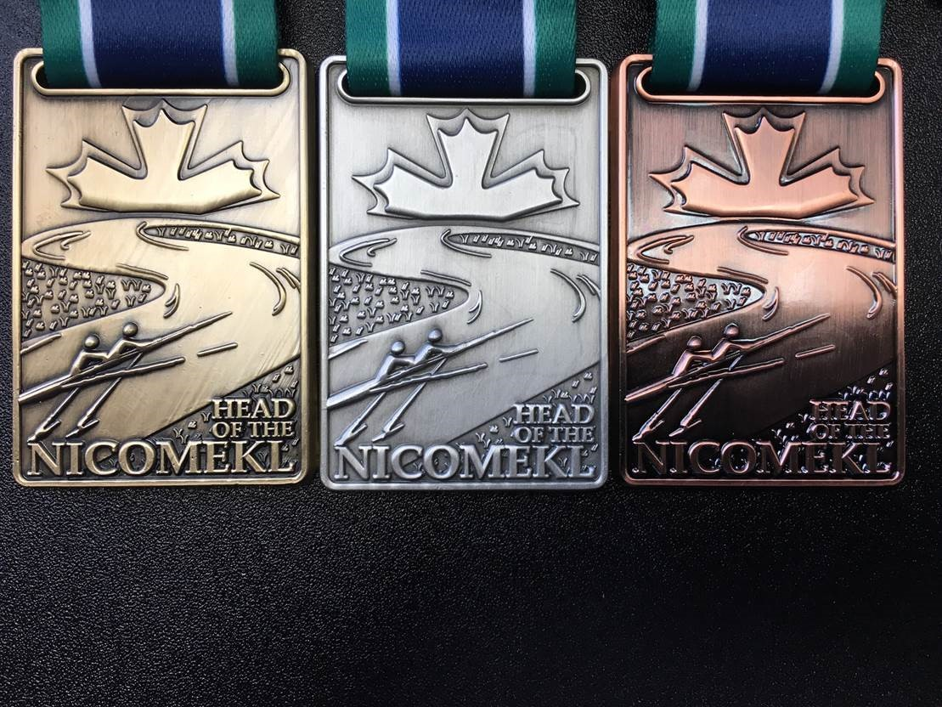

Regatta Package
This Regatta is sanctioned by Rowing BC and races will be governed by the Canadian Rules of Racing defined by Rowing Canada Aviron. RCA Head Race Rules apply (Appendix 4) The start will be a sequential running start. THE OVERTAKING BOAT SHOULD BE GIVEN RIGHT OF WAY WHERE THE BOAT BEING OVERTAKEN, YIELDS THE RACING LINE.

Composite Crews are welcome. They must be designated as Composite Crews at registration. No competitor may compete for more than one club at the same regatta.

Novice rowers are those who were new to rowing after January 2017.

The Location

The Regatta will be held at Blackie Spit Park in Crescent Beach, Surrey, BC. Blackie Spit Park is named after the dramatic spit that extends into Mud Bay at the mouth of the Nicomekl River. This is the best vantage point for cheering on your club members as they round the spit and the finish line comes into view. The park is an environmentally protected area – please take care.

Boats should be offloaded and placed on stretchers at Blackie Spit Park.

The ‘Coaches/Coxswains/Bowperson’s meeting will be in the main tent at 09:30 AM. It is mandatory that at least one representative from each crew attend.

A registration package will be provided at registration.

The Races

The morning race is a Class Race with awards for the top Men’s, Women’s and Mixed crews in each boat class (1x, 2x, 4-’s, 4x and 8+). Trophies will be awarded to the top Novice, Junior, Para and Open sculler or crew. Classes may be combined if insufficient entries for any one class are not received.

The afternoon race is a Trophy Race with all crews handicapped by age, gender and boat type to determine the overall Head of the Nicomekl Regatta winner for 2018.

The Launch

All boats are to be wet launched at the designated beach in Blackie Spit Park. Boats not launching from Blackie Spit will not be considered as regatta participants. Exception: Para rowers may launch from the Nicomekl Rowing Club dock at Ward’s Marina.

All boats must proceed past the Control Commission where the bow numbers will be distributed and heel tie-downs and bow balls will be checked prior to launch.

For the morning Class Race boats must be launched between 9.50 and 10.20 am and ready at the staging area by the start line before 10.55 am.

For the Trophy Race boats must be launched between 12.30 and 1.00 pm and ready at the staging area before 1.35 pm.

Please follow instructions from the Beach Marshalls. No late launching will be allowed.

The Row to the Start

After launching, proceed up river to the start area. Please follow instructions from the Course Marshals. Enjoy the river. Take note of the position of course marker buoys and of any hazards that will need to be avoided while racing back.

All boats must be upriver of the start area by 10.55 am for the Class Race and 1.35 pm for the Trophy Race.

The Start

At the discretion of the Start Marshal, the Class Race maybe split into two flights, depending on the number of boats registered. The 8+, 4-+ and 4x’s will start at 11:05 AM in the first flight and the 2-, 2x and 1x’s immediately following in a second flight. In this instance, 2-, 2x and 1x will be positioned in the designated holding area to allow the larger boats to stage and start the race. Once the 8+, 4+, 4- and 4x’ have passed the holding area, all second flight boats will proceed up river to the start area.
This is a running start headrace. Start between the buoys placed just ahead of the start line.
Follow starter’s orders. Starts will be in sequence of your bow number. It will be a running start with
approximately 15-second intervals between boats.

The Course

The Nicomekl is a tidal river with many turns, shallows and obstacles. Navigation to avoid obstacles and shallows is part of the headrace. There are red navigation buoys along the river. These buoys mark the deep-water channel and are not part of the course. They may be passed on either side.

Two inflatable buoys are placed ahead of the railway trestle bridge. Pass between these buoys. For safety reasons, there must be no overtaking from these buoys until you have cleared the end of the trestle bridge approach. If you are overlapped with another boat, the behind boat must fall back to follow the lead boat. A Course Umpire will be on hand to determine which boat is in the lead – if your bow number is called and you are requested to fall back, you must follow the instructions of the Course Umpire.

The Finish

The finish line is off the end of the pier at Wickson Road. Two buoys will be placed just behind the finish line. Finish between these two buoys.

After the Finish

After the finish turn to port - away from the finish line. Proceed back to the launch area. Keep clear of
boats approaching the finish line staying well to the inside bank and close to Wickson Pier. Please return your bow number!

Results will be posted following the races. Awards will be presented after the Trophy Race at approximately 3 pm.

Boats Not Finishing

If you do not to complete the course for any reason please advise the nearest safety boat.

Risk

Competitors and crews participate in the races entirely at their own risk. The decision to race is that of
the competing crew alone. The organizers will not accept any liability for material damage, personal
injury or death sustained in conjunction with, or prior to, or during or after the event.

Be guided by the rules of good sportsmanship.
Your safety and the safety of other participants are paramount.

Regatta Schedule

9:30 Pre Race Meeting at Registration Tent

CLASS RACE

9:50 – 10:05 Launch window for 1x, 2x, 2-

10.05 - 10:20 Launch window for 4x’, 4-+ & 8+

10:20 Beach Closed – All Boats Must Be Launched

10:55 All Boats at the Start Area

11:05 Start of the Class Race

TROPHY RACE

12:30 - 12:45 Launch window for 1x, 2x, 2-

12:45 – 1:00 Launch window for 4x’, 4-+ & 8+

1:00 Beach Closed – All Boats Must Be Launched

1:35 All Boats at the Start Area

1:45 Start of the Trophy Race

Trophies and Handicaps

We use the best information available in applying a fair handicap that levels the field between male, female and mixed crews, older and younger so that crews can judge how well they rowed against a broad competitive spectrum. We use the age handicapping system developed by John Garrett (Canada) and Carlo Zezza (USA) considering it the best approach available.

The organizing committee seeks to create a rewarding and high-level competitive experience. In order to be awarded first, second or third, there must be at least four competitors in the race. This ensures that each award represents a well-earned result where the competitors fought it out for the top three positions.

EVENT 1 The Class Race

Times are corrected for age only (see handicap table below) to determine the top men’s, women’s and mixed 1x, 2x, 2-, 4x/4x+, 4-/4+ and 8+. Medals will be awarded for the 1st, 2nd and 3rd best adjusted time in each class.

Best Junior Crew Trophy

Open to all entrants under age 18 years. Times are corrected for boat type and gender (see handicap
table below) to determine the Best Junior Crew 2018. The Head of the Nicomekl Junior Cup will be awarded for 1st place with Medals awarded to 1st, 2nd and 3rd place crews.

Best Novice Crew Trophy

Open to all entrants who began rowing after January 1st 2017. Times are corrected for age, gender and boat type (see handicap table) to determine the best overall novice crew. The Head of the Nicomekl Novice Cup is awarded for 1st place with Medals awarded for 1st, 2nd and 3rd place crews.

Best Para Rower Trophy

Open to all categories & classification of rowers. The Head of the Nicomekl Trophy will be awarded for 1st place with Medals awarded to 1st, 2nd and 3rd place crews.

Best Open Crew Trophy

Open to all. Times will be adjusted for boat type and gender to determine the Best Open Crew. The Head of the Nicomekl Trophy will be awarded for 1st place with Medals awarded to 1st, 2nd, and 3rd place crews.

EVENT 2 – The Trophy Race

Nicomekl Head of the River 2018 Trophy
With times corrected for age, gender and boat type (see handicap table) the Head of the Nicomekl 2018 Trophy will be awarded for 1st place, with medals awarded to the 1st, 2nd and 3rd place crews.

APPENDIX 1

Handicap

Age: The Garrett/Zezza formula is applied to the elapsed times based on the average age of the crew as follows:

Age* | Seconds | Age | Seconds | Age | Seconds | Age | Seconds
28 | 0 | 40 | 25 | 52 | 96 | 64 | 198
29 | 1 | 41 | 29 | 53 | 104 | 65 | 207
30 | 1 | 42 | 34 | 54 | 111 | 66 | 216
31 | 2 | 43 | 38 | 55 | 119 | 67 | 225
32 | 4 | 44 | 43 | 56 | 127 | 68 | 234
33 | 5 | 45 | 49 | 57 | 136 | 69 | 244
34 | 7 | 46 | 54 | 58 | 144 | 70 | 254
35 | 10 | 47 | 60 | 59 | 153 | 71 | 264
36 | 12 | 48 | 66 | 60 | 165 | 72 | 275
37 | 15 | 49 | 73 | 61 | 173 | 73 | 285
38 | 18 | 50 | 79 | 62 | 181 | 74 | 296
39 | 22 | 51 | 89 | 63 | 189 | 75 | 307
* No adjustment is made for crews 27 years and under

Gender Handicap: Female crews are adjusted by 10% and times for mixed crews are adjusted by 5%. Mixed crews are those which are up to a maximum of 50% male.

Boat Type Handicap: Applied to Trophy Race, Best Junior and Best Novice.
1x = 0% handicap
2- = 4% handicap
2x = 9% handicap
4- or 4+ = 10% handicap
4x or 4x+ = 15% handicap
8+ = 17% handicap

APPENDIX 2

The Nicomekl River Course

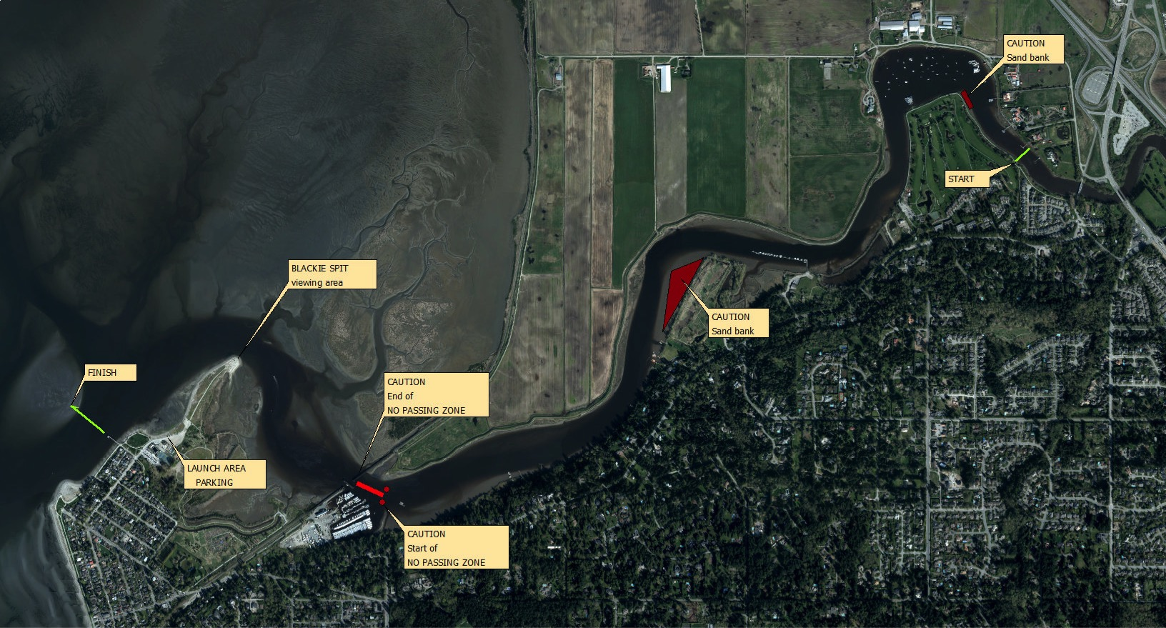

APPENDIX 3

Head of the Nicomekl Regatta 2018
EMERGENCY ACTION PLAN
IN THE EVENT OF AN EMERGENCY, CONTACT THE NEAREST SAFETY BOAT AND HAVE THEM CONTACT THE SAFETY OFFICER:
MR. PETER BOORMAN 604-788-6745
If for any reason the Safety Officer cannot be reached, and the emergency requires immediate attention call 911 and have emergency crews meet at the nearest water access point from the list below or *16 for Coast Guard assistance.
Nicomekl Rowing Club  Elgin Heritage Park  604 543 6700  13723 Crescent Road, Surrey | Crescent Beach Marina  604 538 9666  12555 Crescent Road, Surrey
Nico-Wynd Golf Course  604 535 9511  3601 Nico-Wynd Drive, Surrey | Blackie’s Spit Park  McBride Avenue Crescent Beach, Surrey
Rowers are urged to stay with the capsized hull while they attempt to swim it to shore. The hull is inherently buoyant - it is your Life Raft.
If a rowing shell becomes capsized, wave arms and noise that will alert on-coming rowers who may otherwise not be able to see you.
If you see a rowing shell in need of assistance, contact the nearest safety boat. Do not attempt a rescue from another rowing shell as this may result in two crews requiring rescue.
APPENDIX 4
RCA RULES OF RACING APPROVED JANUARY 28, 2018

Appendix 2 - Head Racing Rules
A Head Race is defined as any race wherein competitors race over the same course but start sequentially. In format, the Head Race is the same as a time trial as described in Appendix 8. The RCA Rules of Racing shall apply in full, except as noted below.

Course
Head races shall be conducted on a course that is wide enough for a participating crew to navigate safely, for overtaking crew to pass another crew, and for non-participating crews to travel to and from a launching area without impeding crews involved in a race. The course shall be identified on the water by buoys and off the water by distance markers at appropriate points along its entire length.

Hazardous areas, such as shallows, underwater obstructions, narrow areas, an area where water traffic crosses a course, shall be conspicuously marked with buoys or other markers that are visible from both directions of the course. The starting area shall have ample room above the start line so that all crews in an event can be marshaled without interfering with the starting line.

The starting line shall be clearly marked to guide crews to the start.The finish line shall be conspicuously marked. The area beyond the finish line shall have ample room to allow crews that have finished a race to row away without interfering with crews still racing. A map of the course indicating traffic patterns and navigational hazards shall be prominently displayed at the launching area. It is the responsibility of the OC to ensure that the RCA Safety Guidelines are followed and that the RCA Regatta Sanction requirements are met.

Local Regatta Rules
For each Head Race, the Organizing Committee (OC) shall devise and publish local regatta rules that govern the conduct of racing and that are adapted to the particular characteristics of the course.
Such rules shall include:
2.1.1 The traffic pattern to be used by crews while launching, traveling to the start area, waiting for the start, racing the course itself, and traveling after the finish.
2.1.2 Right of way rules during the race itself, including any circumstances in which passing is not allowed.
2.1.3 Time penalties to be enforced for violation of the traffic pattern, right of way rules, or violation of course boundaries.
2.1.4 Starting procedures, including the time at which crew must appear in the start marshalling area, the starting interval and marshalling procedures.
2.1.5 The manner in which instructions to crews will be given during the race.
2.1.6 The map of the course showing the starting area, finish area, paths to be taken by launching and returning crews, the location of the first aid station, and the course itself. In showing the course itself, the map shall indicate the location of turns, any known hazardous conditions, course markings, the assigned positions of referees, and any no passing zones.
2.1.7 The OC shall provide for instantaneous communication, such as radio or telephone, between starting line, finish line and any Race Umpire or marshals stationed on the course.
2.1.8 The OC shall provide each boat with a bow marker or a numbering system, unique to its event.
2.1.9 The OC is responsible for providing and operating the timing system for the event.

Umpires
To fulfill RCA regatta sanction requirements, a head race will need a minimum of four RCA licensed Umpires, including the Chief Umpire. In principle, the four Umpires will be assigned to the start area, the finish area, the control commission (launch area) and on- water duties. The timing of races is the responsibility of the Organizing Committee. For each race, the Chief Umpire, in collaboration with the Regatta Chair, will assign Umpires to perform various duties that may consist of the following:
3.3.1 Starter: The Starter shall be stationed on the starting line and shall be responsible for the starting procedure including maintaining order and interval between crews.
3.3.2 Marshal: The Marshal shall be positioned in the starting area and is responsible for organizing participating crews above the start into the proper order.
3.3.3 Timing: The Timer shall be stationed at the start and shall record the starting time of each crew. There needs to be a method for the timing of races. The Chief Umpire should approve the method of timing races and must verify that the Organizing Committee knows how to implement that method, resulting in a fair regatta. However, the Organizing Committee is accountable for ensuring accurate times of the races. There must be at least one analogue back-up to the timing system, in case the electronic system fails.
3.3.4 Race Umpires or Marshals: The Race Umpires or marshals shall be strategically positioned along a course and must have a communication system at points along the course so that no portion of the course is at any time out of sight to one or more Race Umpires’/marshals’ launches.
3.3.5 Launches for Race Umpires/Marshals shall normally be stationary while the race is in progress, but may move to respond to emergencies. Race Umpires or marshals shall note any violation of the local regatta rules, including traffic patterns, right of way rules, passing rules, no passing zone rules, and report such violations to the Chief Finish Judge or the Chief Umpire for the appropriate penalties. Race Umpires or marshals shall give instructions to crews to avoid collision or accident.
3.3.6 Finish Judge: The Finish Judge shall note the order of finish especially in those cases where one or more crews are crossing the finish line at the same time. A member of the Organizing Committee will mark the finish time of each crew.
3.3.7 Marshal or marshals to assist the finish judge.
3.3.8 A Race Umpire or Marshal in the finish area to ensure that finishing crews clear the finish line safely and that crews returning to the docks do not interfere with crews finishing their race.

The Launch Area
In the launch area, there should be an announcing system which updates the regatta time, progress, and delays.
Crews shall gather near the start area with the help of start area marshals. Crews will arrange themselves into their proper race order behind the Start line and await the Starter’s instructions.
7.1 The following commands shall be used:
7.1.1 The Starter or the Marshal will instruct the crew “Crew #1 Alberta, on the paddle”.
7.1.2 As the crew approaches the line, the Starter will say “Crew #1 Alberta, approaching the line”.
7.1.3 As the crew crosses the line the Starter will then say “GO”, or, sound a horn
7.2 As each crew finishes, the Finish Judge will say “Down” or sound the finish horn.
7.3 The Finish Judge shall mark the finish order of each crew.

The Start
Before the start of each event, the Marshal, Starter and Timer shall verify the presence of scheduled crews. Any crew that does not appear within the time specified in the local regatta rules may be warned or excluded by the Marshal or Starter.

Penalties
Time penalties: The OC may provide in the local regatta rules for the imposition of time penalties, to be added to a crew’s elapsed time, for violation of the traffic pattern, right of way and passing or no passing rules or violation of course boundaries.

