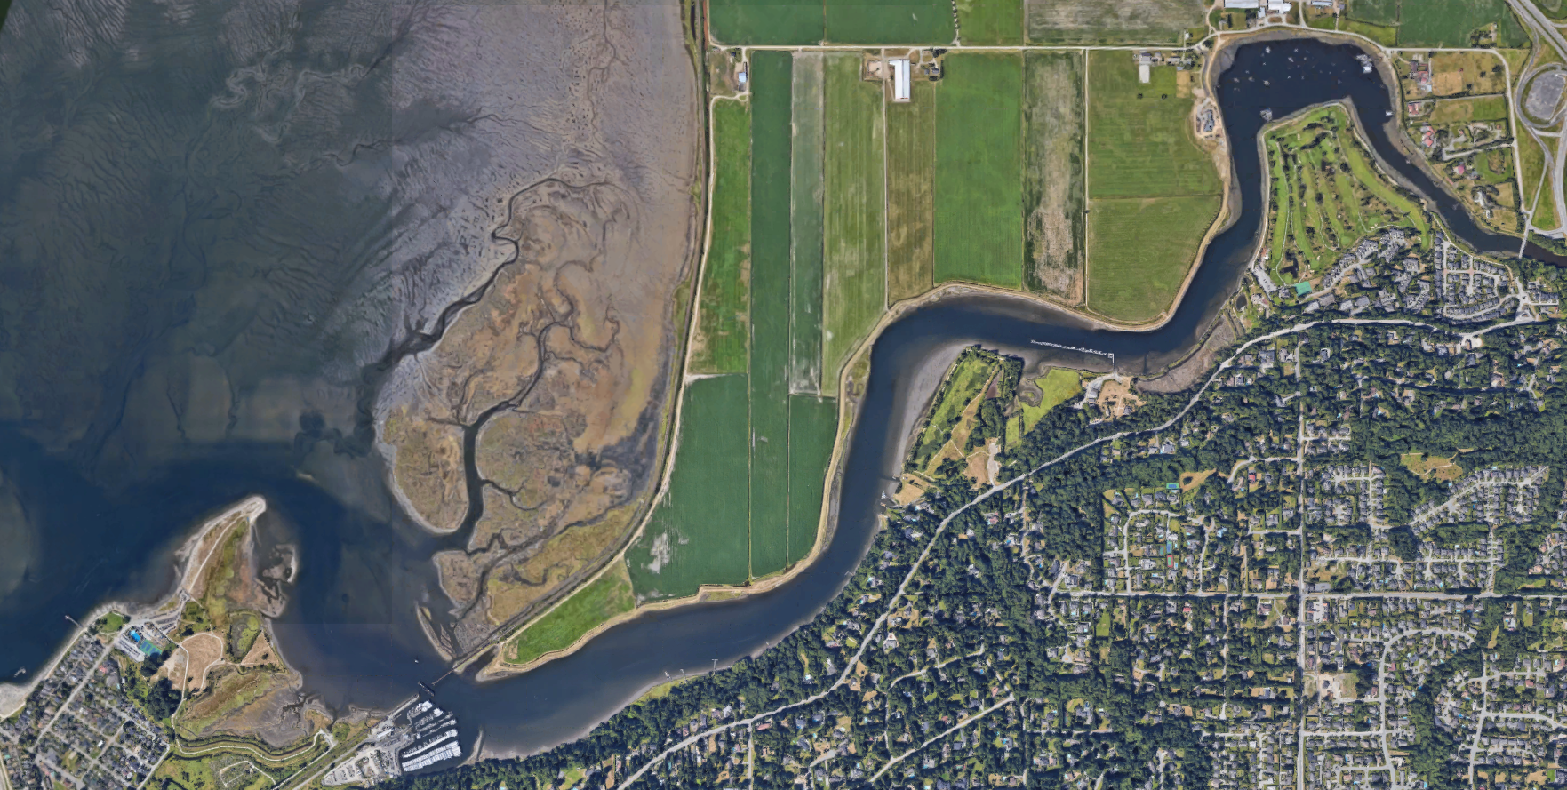

Blackie Spit viewing area

Course marker bouys keep on Starboard side

Start

No passing zone (3rd buoy to tressle)

CAUTION Sand bank

CAUTION Sand bank

CAUTION Sand bank

Launch Area & Parking

Finish