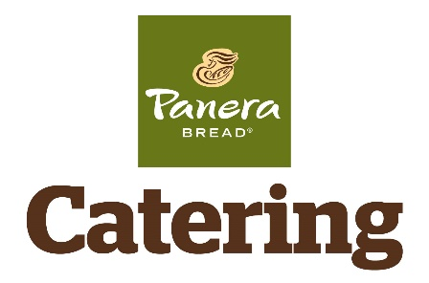

**Day / Date: __________________________**

**Pick Up Time: _______________________**

**Panera Catering Tent @ Melton Hill Lake**

Friday, 4/27 7:00am – 3:00pm

Saturday, 4/28 7:00am – 3:00pm

**Dogwood Junior Championship – 2019**

**BOXED LUNCHES**

Includes Bag of Chips & Cookie | Condiments on Side

Quantity **SANDWICHES - $9.19** Quantity **SALADS - $9.19**

________ Heritage Ham & Swiss ________ Caesar

________ Mediterranean Veggie ________ Seasonal Greens

________ Turkey ________ Greek

Quantity **SANDWICHES - $10.19** Quantity **SALADS - $10.19**

________ Bacon Turkey Bravo ________ Caesar with Chicken

________ Napa Almond Chicken Salad ________ Greek with Chicken

Return via email to: **Taylor Lindsay**

Email: **Taylor.Lindsay@PaneraBread.com**

Phone: **865-306-2850**

**CONTACT INFORMATION**

Team Name: _______________________________________________________

On-Site Contact: ____________________________________________________

Mobile Number: ____________________________________________________

Email: _____________________________________________________________

MyPanera Rewards | Account or Phone Number: _______________________