Cromwell Cup
REGATTA PACKET
Welcome! Thank you for attending Riverside Boat Club’s Cromwell Cup! Please read the entry packet and adhere to the procedures. We hope you enjoy your racing. All questions can be directed to the registration / information desk on the 2nd floor of the boathouse.
Lane draws for heats, finals, and RESULTS will be available in 3 places. 1) On boards in front of the boathouse on the lawn, 2) boathouse porch overlooking the dock, 3) Registration Desk. There will also be a separate announcement board on the front law to relay announcements such as delays, race cancellations, etc.
ALL CREWS must register PRIOR to racing, Sunday morning at the 2nd floor registration table. Any registrants with unpaid balances will not be permitted to launch for races.
There will be a coach/coxswain meeting at 6:00am Sunday to review the traffic pattern, procedures, and answer any questions. This is meeting is recommended, especially for new participants. Racing begins promptly at 7 AM with Women’s 500m Dash Heats.
Racing Format:
Morning 1000m Heats:
All heats will be 1000m races from a standing start that begins downstream of Weeks Footbridge and ends downstream of the Riverside dock.
Afternoon 1000m Finals:
All finals will be 4-lane 1000m races from a standing start, on the same course as the morning heats.
500m Dashes:
The course of the Open 1x and Mixed Open/Masters 8+ 500m dashes will begin before the River Street Bridge (painted line on sea wall indicates starting line) and end past the Riverside Dock at the same finish line used for the 1000m course.
Progression:
Entries | Heats* | Advance From Heat 1 | Advance From Heat 2 | Advance From Heat 3 | Advance From Heat 4
4 or less: | FINAL ONLY | N/A | N/A | N/A | N/A
5 | 2 | 2 (heat of 3) | 1 (heat of 2) | N/A | N/A
6 | 2 | 2 (heat of 3) | 2 (heat of 3) | N/A | N/A
7 | 2 | 2 (heat of 4) | 2 (heat of 3) | N/A | N/A
8 | 2 | 2 (heat of 4) | 2 (heat of 4) | N/A | N/A
9 | 3 | 1 (heat of 3) | 1 (heat of 3) | 1 (heat of 3) | N/A
10 | 3 | 1 (heat of 3) | 1 (heat of 3) | 1 (heat of 4) | N/A
11 | 3 | 1 (heat of 3) | 1 (heat of 4) | 1 (heat of 4) | N/A
12 | 3 | 1 (heat of 4) | 1 (heat of 4) | 1 (heat of 4) | N/A
13 | 4 | 1 (heat of 4) | 1 (heat of 3) | 1 (heat of 3) | 1 (heat of 3)
14 | 4 | 1 (heat of 4) | 1 (heat of 4) | 1 (heat of 3) | 1 (heat of 3)
15 | 4 | 1 (heat of 4) | 1 (heat of 4) | 1 (heat of 4) | 1 (heat of 3)
16 | 4 | 1 (heat of 4) | 1 (heat of 4) | 1 (heat of 4) | 1 (heat of 4)
* Any seeding is performed by Regatta Committee with goal of maximum fairness and fastest boats in each final
** Maximum of 16 entries per event. First 16 registrations are accepted.
1Bow Numbers:
Competitors that own bow numbers are encouraged to bring and use them. Please check the heat sheet on the Friday before the race (www.regattacentral.com) for your lane assignment (It will be between 1 and 4 as we have a 4-lane race course). Riverside Boat Club will have bow numbers available on the dock for boats requiring them – they MUST be returned to the dock.
Launching and Receiving area:
Launching
- Oars down first
- Boat enters dock STERN FIRST using SWING DOCK on upstream side of boathouse
- Cox or Coach to accompany crew boats at all times
- Please make effort to launch and depart dock in 90 seconds
Hot seating:
Coaches please notify the dock master prior to hot seating. You will have 2 min to hot seat a boat. Please have oars and rowers available to make process quick and easy.
Landing:
After completing your race, YOU MUST continue rowing past the finish line beyond the sign. Feel free to cool down towards the BU bridge. When landing, help us keep the dock clear by having a coach or teammate take your oars. Please EXIT the dock using the downstream ramp – carefully walking your boat through the RBC work bay and out onto the driveway.
Coaches are to leave dock area once boats are on the water and oars are in oar locks, please limit pre-race speeches on the dock. Let them race! Coaches – please wait until crew has landed to return to the dock. This is a safety measure to limit dock traffic.
Traffic Pattern:
Please see attached map to review traffic pattern
1000m Heats AND Afternoon Finals:
Warm up area traffic must follow counter clockwise pattern between Weeks Bridge and Anderson Bridge. Please be aware of other crews and boat traffic going through bridges. We suggest that you go upstream past Anderson Bridge to completely warm up before returning to pre-race staging area.
500mDashes:
Starting line for 500m course will begin between the River St Bridge and Western Ave Bridge on the Powerhouse Stretch. The line is painted on the sea wall on the Cambridge side of the river.
500m Dash Safety:
Warm up area traffic for dashes must follow the same counter clockwise pattern as the 1000m heats (between Weeks Bridge and Anderson Bridge) and obey normal river rules. AFTER, and ONLY AFTER the final 1000m heat/final has begun may you extend your warmup area to encompass the first 500m of the 1k course. You may go upstream past Anderson Bridge to completely warm up before returning to pre-race staging area downstream of Western Ave bridge.
Be aware there will be referees near each bridge directing boats going up the racecourse (from the dock towards the starting line) to stop or proceed. Listen to these officials - they are watching out for your safety. Referees can disqualify crews for not adhering to safety commands.
Docking /Receiving:
Please row through finish line area and row around the buoy indicated on the traffic pattern map. If you need medical attention raise hand or call out to race referees, finish line officials or Dept of Recreation/Conservation Rangers. Please clear the finish line when you are able. This is a safety measure as races are run on close centers and the finish line must be clear of traffic for oncoming boats.
Please limit your time on the dock to 90 seconds once you have landed to remove oars and leave the receiving area via the downstream dock ramp that leads through the boathouse work bay. Help keep the dock area clear!
Racing:
To borrow a line from the Independence Day Regatta, the safest and fairest way to run the Cromwell Cup which features over 100 races over the course of 11 hours is to stay ON TIME. Regatta time is "cell phone time." Unless an official announcement is made, ASSUME YOUR RACE IS ON TIME. We will make every effort to stay on schedule and make up for minor delays. Regardless, you must be in position, near the start line, downstream of the Weeks Footbridge 5 minutes before the scheduled time of your race. If you are late to the for any reason, your event will not be delayed, and YOU WILL MISS YOUR RACE.
Any protests of races are to be filed upon race completion on the water to the referee who will report to the finish line the race is under protest. The finish line official or regatta chair will receive incident descriptions from the referee following the race and the protesting crew. Once landed, the protesting crew should proceed to the information table for protest resolution within 1 hour. A decision will be made by the chief referee and/or regatta chair within one hour of protest submission. In order for us to decide a protest in your favor, you must have been in a position to advance to finals (if protesting a heat) or a position to win (if protesting a final.) Generally, this mean you must be/finish in 2nd place. Safety infractions will not be tolerated.
IT IS YOUR RESPONSIBILITY to be at start line 5 minutes before the scheduled time of your race whether you hear an announcement or not.
Starting Commands:
Cromwell Cup will use the following floating command procedure.
- Aligner will call boats to the line and align them. When alignment is called, you should be sitting ready for the start of the race. Hands will not be recognized after alignment is called. You are responsible for your own point.
- After alignment is announced, the starting commands will closely follow.
- Countdown sequence may or may not be used, at the discretion of the starter. The entire starting sequence is as follows:
  - "We have alignment" (hands will NOT be recognized after this point)
  - "This is the start"
  - "5-4-3-2-1" (if countdown start is used)
  - "Attention"
  - (variable pause, from 1 to 5 seconds in length) "Go!"
Once racing you are responsible for your own point. The referees and launches are there for your safety. Please follow their commands. Should you drift off-course, they will announce your lane and wave a flag to the direction you should adjust towards. For coxed boats, stroke seats or bow seats may have to notify their coxswain if the crew is directionally flagged by an official.
Medals:
Medals for 1st place (winning crews only) will be distributed on the dock following each final.
Rest rooms:
Signs will direct participants to indoor facilities. Additionally, portable potties will be available for use. Please help us keep the boathouse clean!
Parking:
See attachment.
Scheduling & Lineup Changes:
Final Race Schedule and Lane Assignments will be provided via email on or before Friday, July 10th and online at www.regattacentral.com and at the registration table on the 2nd floor of the boathouse on race day. Note: schedule may be changed due to time constraints. Heat and final sheets, as well as results, to be provided throughout the day on the Riverside Dock and on boards on the lawn in front of the boathouse and at Registration Desk.
Heats – No changes in heat lanes or times will be allowed unless explicitly approved by Regatta Committee by 5pm on FRIDAY July 10th.
Finals – No changes in final lanes or times will be allowed.
Entries close at midnight on TUESDAY, July 7th. Preliminary heats will be posted by THURSDAY, July 9th on www.regattacentral.com and will be emailed to all participants. Final lane draws will be available in the afternoon on FRIDAY, July 10th and will be posted on race day.
Lineup Changes – Changes to lineups, including MASTERS crews (for handicap purposes) must be submitted NO LATER THAN 5PM, FRIDAY July 10th via email to mwvanneman@gmail.com. Masters lineups will be frozen at 5pm, 7/10/08.

REGATTA PARKING

- During all Riverside Regattas, parking in the lot next to Riverside Boat Club is reserved for trailers. car top boats may park on a limited first-come, first-serve basis. For most cars, equipment/people drop off is permitted but you must park elsewhere.
- TRAILERS – please, PLEASE – do NOT park on the grass.
- Should your TRAILER arrive Saturday night, please park towards the edges of the parking lot and notify the regatta chair ahead of time. We may ask you to adjust your parking spot on Sunday morning.

Where you may park:

- Sundays only (REGATTA ON SUNDAY!) – City of Cambridge on-street parking is legal for all non-residents (any side street, do NOT park on Memorial Drive)

- The Morse School – Across from the pool and the Sunoco Station, there is an elementary school. Parking there on weekends is legal, UNLESS THEY HAVE A FARMERS MARKET SCHEDULED (markets typically on Saturdays only). Watch for signs.

- The "Horseshoe" – across from the Shell Station near Magazine Beach, adjacent to the pool.

- Magazine Beach ball fields – Next to the BU Bridge (stay right of the overpass when you travel past Riverside on your right, entrance shortly after). Several parking spaces exist between the ball fields and the pumping station.

- City of Boston streets – on street parking is legal in Allston, on the other side of the river. Western Ave is the most accessible location, and can be reached by crossing the Western Ave. Bridge, 2 bridges above (west of or upstream of) Riverside.

THOU SHALT NOT PARK:
- Anywhere on the grass (that means no parking on any grass). Warning: The state of MA will tow your car!

- In the MicroCenter/Strawberry’s/Trader Joes parking lot during store hours. They WILL TOW!

- At the Radisson

Any parking lot associated with a business that has not given us permission.
- 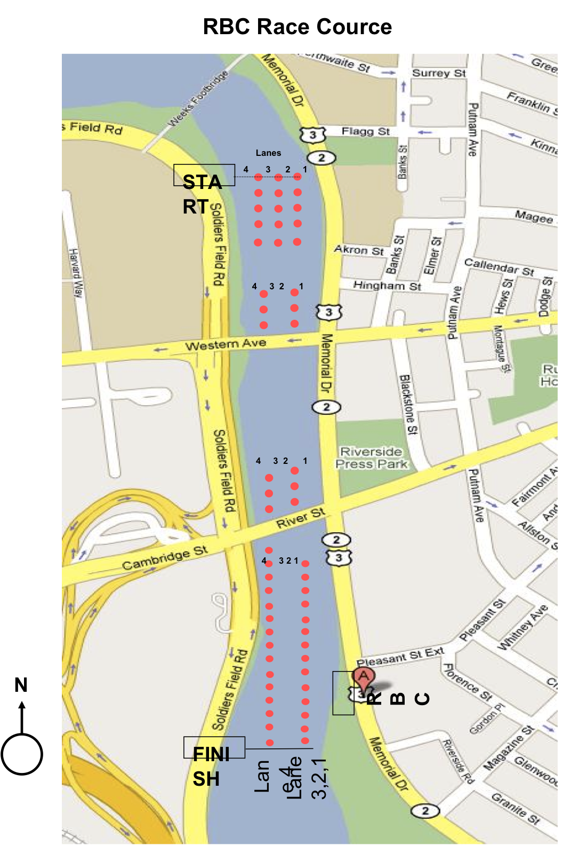
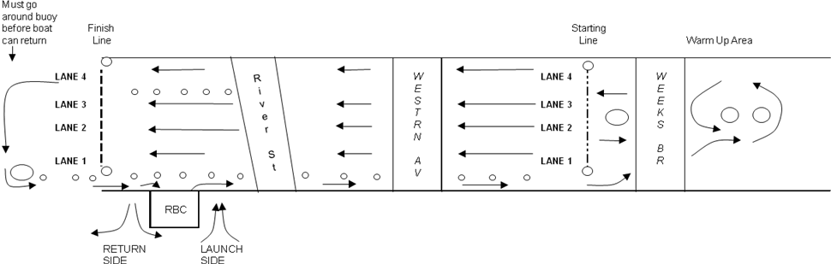
First Call from Dockmaster: 35 minutes prior to Race

Last Call from Dockmaster: 15 minutes prior to Race
LANDING PROCEDURE: Please exit the dock using the downstream ramp that leads through the boathouse work bay and onto the driveway. This will facilitate easy traffic flow. Please use care walking through the work bay!

