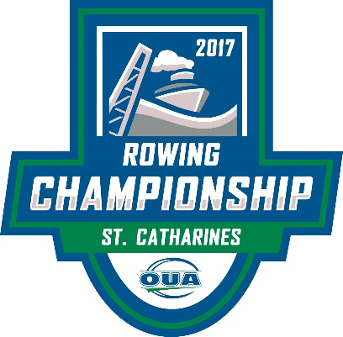

Thank you for your interest in being a vendor at the 2017 OUA Rowing Championships. To reserve space, please submit your application as soon as possible.

**Event Information**

The 2017 OUA Rowing Championships will be held on October 27th and 28th at the Canadian Henley Rowing Course. Hosted by ROWONTARIO, the OUA Championships are an opportunity for university rowing programs in this province to compete for gold, silver and bronze medals in 20 varsity events, as well as vie for the overall points banners. There are also 10 Development events for novice, para and future varsity athletes.

14 university programs are expected to participate in the 2017 OUA Rowing Championships from across Ontario, plus McGill from Montreal. Friday October 27th will be the Development heats and finals in the morning, and the heats for the varsity finals in the afternoon. Racing on Friday will be from approximately 9:00AM – 4:45PM. Saturday’s varsity finals will be from approximately 9:00AM-1:00PM, followed immediately by the medal, banner and awards ceremony.

Please note that Sunday is reserved as a back-up day for racing should weather prevent racing on Friday or Saturday. Vendor privileges will be extended to Sunday should that happen. ROWONTARIO will not provide a refund racing is condensed or cancelled.

The Henley Grandstand will not be open for the OUA Championships, so all spectators will be watching from the island and there will be no charge for admission or parking.

**Vendor Information**

Vendor Fee: $150

Vendors are welcome to set up in the Vendor area across from the Henley Island Helpers building. Vendors must provide their own tent and any required tables and chairs.

Merchandise should be removed over night, as there will be limited security. ROWONTARIO and OUA are not responsible for any merchandise or vendor property. Vehicles will be allowed in for drop-offs and pick-ups only, but must be moved by 8:00AM daily. Parking is available at the south end of the island, close to the vendor area.

Wi-fi is available for purchase on the online login if required.

**Please make cheques payable to *ROWONTARIO* and submit with a completed application form to *Andrea Miller c/o ROWONTARIO 206-19 Waterman Ave. Toronto, ON M4B 1Y2***

**Payment may also be submitted by credit card.**

Our goal is that all athletes, coaches, officials, volunteers, spectators and vendors enjoy a great regatta experience. Please let me know if there is anything I can do to assist you.

Andrea Miller

ROWONTARIO Competitions Manager

**Additional Vendor Terms and Conditions#3 #4 #5**

1. FEE AND PAYMENT TERMS. Vendor hereby agrees to pay the Vendor Fee set out in this Agreement which fee is immediately due and payable. Vendor Fees are in CDN $ and are subject to HST.

2. CANCELLATION POLICY. ROWONTARIO retains the right to cancel or revise the regatta for any reason in its sole and unfettered discretion. Refunds will not be provided. Upon receipt of this Agreement signed by the Vendor representative, Vendor will be responsible for **100%** of the contracted amount. No cancellations by Vendor will be accepted.

3. EXHIBITS

3.1. ROWONTARIO and OUA shall have the right to determine the eligibility of exhibits, including, but not limited to: companies, products, systems, services, graphics, printed matter distributed at the regatta and all other event features and activities. ROWONTARIO or OUA may withhold and/or withdraw permission to distribute any materials it considers objectionable. Food or beverage distribution is not permitted.

3.2. ROWONTARIO and OUA reserve the right to restrict exhibits because of noise, odours, size and method of operation or for any other reason they become objectionable or otherwise detract from or are out of keeping with the character of the regatta as a whole. This reservation includes, but is not limited to, persons, things, conduct or printed material.

3.3. Subleasing: Vendor shall not allow any other corporation or firm or its representatives to use the exhibit space allotted to Vendor, nor shall Vendor display articles, things, handouts, and/or all other promotional materials, not normally sold by Vendor.

4. ADVERTISING/PUBLICATIONS. As a material obligation of this Agreement and except as otherwise expressly consented to by the applicable owner in writing, Vendor shall not use the name, logo or trademarks of any ROWONTARIO or OUA party or any confusingly similar versions of such in any way including, without limitation, in advertising, marketing, public relations or similar publications or related media in any location whether at the regatta site or elsewhere.

5. COMPLIANCE WITH LAWS. Vendor is responsible for compliance with all applicable laws and regulations.

6. INDEMNIFICATION, INSURANCE. Vendor shall, at its own expense, indemnify, defend and hold harmless ROWONTARIO and OUA and each of their respective directors, officers, employees, agents, successors and assigns and all other persons and entities acting on their behalf of or under their control from and against any and all losses, damages and costs (including all reasonable legal fees)arising out of, or concerning or connected with, Vendor’s participation at the OUA Rowing Championships or any of the transactions or activities contemplated by this Agreement. Vendor shall have appropriate insurance to cover its activities and its obligations under this Agreement including the foregoing indemnity.

7. GOVERNING LAW; LIMITATION OF LIABILITY. This Agreement shall be governed by the laws of the province of Ontario and the federal laws of Canada applicable therein. ROWONTARIO AND OUA (OR THEIR RESPECTIVE REPRESENTATIVES) SHALL HAVE NO LIABILITY TO THE VENDOR UNDER THIS AGREEMENT FOR ANY DAMAGES OF ANY KIND, INCLUDING DIRECT, INDIRECT, PUNITIVE, INCIDENTAL, EXEMPLARY, SPECIAL OR CONSEQUENTIAL DAMAGES.

8. GENERAL. This Agreement shall constitute the complete and final expression of agreement between the parties and supersedes all previous or contemporaneous agreements or representations, written or oral, with respect to the subject matter described herein. No course of prior dealings between the parties, no course of performance and no usage of trade shall be relevant to determine the meaning of this Agreement even though the accepting or acquiescing party has knowledge of the performance and opportunity for objection. This Agreement may not be in any way whatsoever modified or amended except in a writing signed by a duly authorized representative of each party.

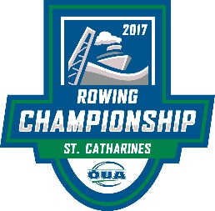

**2017 OUA ROWING CHAMPIONSHIPS**

**VENDOR AGREEMENT**

**Company Name:**

**Contact:**

**Address:**

**City: Province: Postal Code:**

**Email Address:**

**Phone Number:**

**Expected Set-Up Time:**

**Expected Tear Down Time:**

**Description of Wares/Services to be Exhibited:**

**Price: $150 + HST**

I have mailed a cheque made payable to ROWONTARIO to Andrea Miller c/o ROWONTARIO 206-19 Waterman Ave. Toronto, ON M4B 1Y2

I wish to pay by credit card. Please send me an invoice to the email address listed above.

**PLEASE NOTE:**

**All vendor applications are subject to ROWONTARIO and OUA approval.**