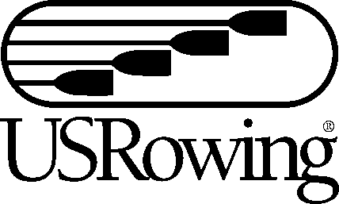

YES! We will be attending the college fair.
Please share my information with attending collegiate coaches.

Club Name:
Coaches Name:
Coaches Contact Information:
Athlete Name | Athlete E-mail address

**PLEASE NOTE ONLY HIGH SCHOOL SENIORS FOR THE 2010-2011 SCHOOL YEAR MAY ATTEND THE COLLEGE FAIR IN ACCORDANCE WITH NCAA RULES**
Please return completed form to Jackie@usrowing.org no later than Friday, July 9. College fair registration will also be available at the registration tent beginning Tuesday, July 13.

