Cadborosaurus Coastal Endurance Regatta
Sunday, April 10th, 2022

The Victoria City Rowing Club is proud to present our first Cadborosaurus Regatta. This regatta is an opportunity for all open water and coastal rowers to start off their racing season with a bit of an endurance event.

It will bridge the gap between open water and traditional flatwater rowing and show that people can be members of one whole rowing community. Flatwater rowers are more than welcome, in fact encouraged, to try it out.

Coastal Rowing is the “mountain biking” of rowing. Navigating the currents, winds, and waves makes it a particularly challenging an exciting event.

The packet below contains regatta information, as well as some information about the venue. Be sure to read it in its entirety, as all competitors are responsible for any information detailed in this packet.

All races will be in boats designed for rowing on open water (flat water racing shells will be excluded) and will follow Rowing Canada Aviron’s Rules of Coastal Racing (January 30, 2022, revision). The race course starts on the beach, with the course heading into Cadboro Bay and around Flower Island and Evans Rock, before heading back to shore with a turn, approximately 25 – 50 meters from shore (depending on tides) to have the final meters parallel to the shore. Races could have up to 6 crews racing in each race.

We have two key priorities for this year’s Regatta:
- The safety and health of athletes, coaches, volunteers and spectators.
- FUN, competitive racing.

We look forward to hosting you this year.

Venue location Parking (very limited parking – esp. on sunny days)
Cadboro Bay – Gyro Park Gyro Park parking lot
2625 Sinclair Road, 2625 Sinclair Road,
Victoria, BC, V8N 6B4 Victoria, BC, V8N 6B4

COVID-19 Policy
We have set the COVID-19 Policies in place as are in effect as of February 22nd, 2022. Please refer to the COVID Safety Plan for additional information. Any changes will be based on those provided by ViaSport & Rowing BC.

Vaccinations
• It is expected that all regatta participants, coaches, volunteers, and spectators are to be fully vaccinated.

Masks
- It is strongly recommended that all regatta participants and spectators wear masks. Those who are not fully vaccinated (two weeks after the second shot) must always wear masks, except athletes when they are racing.
- All participants should have an ample supply of masks, hand sanitizer and bring personal hygiene
items to the venue.

Social Distancing
• All participants are encouraged to maintain social distance from others throughout the regatta.

Day-of Illness
- If you are feeling unwell or have any of the symptoms associated with COVID-19, do not come to the regatta! Contact your coach immediately so that he or she can make alternative arrangements for your boat.
- Anyone experiencing any of the symptoms of COVID-19 must immediately report to the Regatta Director.

RCA Membership
All rower participants must hold an active membership with their Provincial Rowing Association and Rowing Canada. Any USA competitors must be registered with US Rowing.

Entry Information
All entries should be made online at RegattaCentral. Initial registration will be available beginning March 7th, 2022 and ending April 5th, 2022. No refunds will be given once the initial registration period has ended.

Entry fee
Entry fee = $25 / seat / event (plus RCA & RBC seat fees)

Rules of Racing
The race will follow the RCA Rules of Racing (January 30, 2022, version) for Coastal Endurance.

Age categories for rowers for Endurance
1. Junior = Under 19
2. Open = 19+
3 Masters = 27+

Boat class for Endurance
1. Solo (C1x)
2. Double Sculls (C2x)
3. Coxed Quadruple Sculls (C4x+)

Endurance for the following events:
The following Women’s (W), Men’s (M) and Mixed (Mix) events are offered in Coastal boats:

Events: Junior; Open; Masters | Men | Women | Mixed
Solo | CM1x | CW1x
Double | CM2x | CW2x | CMix2x
Coxed Quad | CM4x+ | CW4x+ | CW4x+

Event Schedule Outline (Please refer to the attached preliminary schedule further below)
This schedule could be amended depending on the number of entries.

Boats
Rowing craft designed for rowing on open water (i.e., coastal boats) will be permitted to race. Boats used for flat water racing will be excluded for safety reasons. Coastal boats are much wider and more robust than flat water racing boats, designed specifically for dealing with waves and maneuverability in rougher water. The design greatly reduces the likelihood of capsizing or sinking.

All racing craft will be inspected prior to racing.

These are currently the Coastal Rowing shells we have available therefore max. number of boats per flight. For example, unless people bring their own shells, the maximum number of shells in a C4x+ race will be 4; C2x’s = 6 and Solo’s = 7.

Source | C1x’s | C2x’s | C4x+’s
VCRC | 3 | 1 | 2
OARCA |  | 2
LiteBoats | 2 | 2
Westcoast Rowing Adv, | 2 |  | 2
Brentwood College |  | 1 | 1
Total | 7 | 6 | 4

Those bringing their own boats must meet the requirements under the RCA Rules of Racing – Coastal Rowing

“Boat Usage fee” – those not bringing their own boats
If people need to rent boats, then it’s a $25 / seat rental fee

Length of the Course:
- Endurance: Approx. 3,500m (in total)
- Out, around islands, and back course

Endurance
In this endurance format, the crew race 3.5 km thus technical and physical skills are crucial.

As a coach, spend time teaching the crews to recognize when and how to adapt their rowing style to different conditions. In a strong headwind, bow waves or negative tide currents the crews need to use their skill to minimize the slowdown. In tailwind, stern waves or positive tides currents the boat speed accelerates thus the rowing style/technique should change.
The start is a mass start from the beach. All rowers will be out of the boat until the whistle / horn blows for the start. It will be their option whether they stand in the water or on shore while awaiting the starting signal. In any case, one or two people (depending on conditions) will be required to hold the boat with bow pointing in the direction of the course and ensuring sufficient water under the keel to avoid breakage.

There is typically an advantage in getting into the lead group. The water tends to be cleaner and the potential for multi-boat collisions is less. Avoiding collisions with other boats at the turning point around the island is important. Learn how to use the wind and tide to position your boat to your advantage.

Course – Characteristics
Use caution rounding “Flower Island” and “Evans Rock” to ensure you have sufficient water under the keel until fully rounded and heading back for the finish line. Because of the width there will be a “No Passing” zone just prior to entering the narrow channel between the shore and Flower Island. Any infractions will result in time penalties.

SCHEMATIC of racecourse attached below – start with the boats on water, at beach. There are no turning buoys at the numbered waypoint areas – these indicate sequence for race.

Course Markers
A plan of the course(s) showing the location of all course markers is included in this document. As well they will be available for all crews upon arrival at the regatta.

The organizing committee will ensure that there is sufficient water to allow for safe rounding of Flower Island.

Note that the layout of the course is such that boats will be travelling in opposite directions in the same water. As such, use caution on the return leg of the course and stay further away from the northeastern shore to avoid conflict. A safety boat will be on the water to observe and direct as appropriate. However, it will remain each crew’s responsibility to watch your course.

Equipment
All equipment used in competition must meet the RCA Rules of Rowing requirements for equipment.

Buoys
There will be two buoys laid out, perpendicular to the shore, to designate the finish line.

There will be a larger turning buoy, about 20m off shore and approximately, 50m before the finish line to designate the point where you have to turn to go through the designated finish line.

Start and Finish Lines
- The start will be from the beach with boats in the water, pointing towards Flower Island & Evans Rock.
- Depending on conditions, you may want to have boat-holders available to assist.
- Also, depending on conditions, we may allow bow-pair & coxie to already be in the boat
- The start line shall be wide enough to allow all rowers in the race to align and start at the same time.
- The finish line shall be on the water, perpendicular to the shore, requiring a left hand turn around the turning buoy.
- Crews MUST go through the finish line between the finish line buoys.
Race results
With the race being a mass start, the various crews will be handicapped based on type of boat, gender, and age. The handicap system used will be the Dutch system.
Every “Flight” will be a race unto itself. Should time allow, we may be able to schedule a final race(s) for winners of each flight.

Uniforms
There are no uniform rules. Just ensure you wear appropriate gear with understanding of the likelihood of getting wet.

!! Water socks or water shoes SHOULD be worn for safety’s sake !!

Boat and Crew registration numbers
For identification of the crews, identification numbers will be assigned to every boat.

Regatta Chair
The organizing committee has appointed a Regatta Chair. The Regatta Chair will work and cooperate closely with the Chief Umpire. He will participate in any decisions in case of adverse weather conditions.

In any case where the Regatta Chair and the Chief Umpire are not in agreement on an issue regarding safety, the decision of the Chief Umpire shall prevail.

Meeting before the regatta begins – Regatta meeting
Crew Captains’ and Coaches Meeting will be in the morning and will be convened by the Chief Umpire. With the current expected schedule, the meeting will commence at 7:45am.

At this meeting, the Chief Umpire and/or the Regatta Chair will explain and provide to all participants details regarding the regatta rules, start and finish procedures, penalties etc.

Crew Captain’s obligations
According to international maritime law, all sea-going vessels must have one person responsible for safety and navigation. In Coastal Rowing, this will be one member of the crew who will be designated as the “Crew Captain” by the crew. The designated Crew Captain for every boat shall be notified to the organizing committee in writing at the time of the crew’s Registration. Such notification is the responsibility of the crew. Any crew for which a Crew Captain has not been notified/appointed, the regatta registration team will appoint one member of that crew as a Crew Captain.

The Crew Captain shall be responsible to: Before every outing:
- Take responsibility for assessing the risks and the ability of the crew to cope with the prevailing and forecast conditions.
- Familiarize themselves with the current and expected weather conditions.
- Check the condition of the boat and the safety equipment on board.

During the outing:
- Ensure that the crew respects all navigational and safety rules.
- Require that all members of the crew wear their life jackets as necessary.
- Make necessary decisions for the safety of the crew if the weather deteriorates.
- Monitor any changes in the weather or water conditions, which might affect the safety of the crew.

After the outing:
- Inform the Control Commission of any concerns with the equipment

Collisions
In case of collisions (of boats or oars), and if one of the crews’ protests, the Umpire shall decide
who is at fault and may impose a penalty on the boat responsible for the collision.

Avoiding collisions
When two rowing boats are on a potential collision course, both boats should move to starboard to give way to the other boat. For clarification, “starboard” means the left-hand side of the rowers as they are sitting in the boat
Adverse Weather Conditions
The Chief Umpire, in consultation with the Regatta Chair and the organizing committee, shall take all decisions on any delay, postponement or cancellation of races, or of changes to the course, resulting from adverse weather conditions or other matters relating to the safety of rowers and equipment and officials on the water or the fairness of the course.

At the Start
There shall be no start zone in Coastal Rowing events. Crews are responsible for their own equipment if there is damage. Crews must be in the vicinity of the start line two minutes before the designated start time. The Starter may start the race without reference to absentees.

The Start Procedure
- The start will be from the beach.
- The boats will be lined up and positioned by the organising committee.
- Approximately 5 minutes before the start, they are to be placed in the water and, either held by handlers or crew, pointed in the direction of travel.
- The Starting Umpire will give the 5 minute, 4 minute, 3 minute warnings.
- At the 2 minute warning all crews must be in place ready to launch.
- At the start time the Starting Umpire shall be clearly visible. They shall say “Attention!” and, after a clear pause, shall give the starting signal by dropping the flag and simultaneously announcing “Go!” in a loudhailer or sounding a horn in one long blast.

False Start
A crew commits a false start when any part of its crew enters the boat prior to the announced starting signal.

Multiple False Start
If in a race the Judge at Start indicates that a number of boats have committed a false start, the Starter may decide to stop the race and give the start again or he/she may allow the race to continue and award penalties to all boats concerned. If he/she decides to stop the race, the Starter shall do so by raising a red flag and sounding repeated short blasts on the megaphone.
Where there is a mass false start caused by weather conditions or other external influences, but the Judge at Start considers the start to have been fair, he/she may advise the Starter to allow the race to continue with or without penalties to individual crews.

Consequences of a False Start
A crew committing a second false start shall be allowed to continue with the race but shall be awarded a time penalty of 2 minutes. When conditions allow a red flag to be raised to indicate one or more crews are carrying a false start penalty.

Responsibility of the Rowers
When turning around the buoys, crews are permitted to touch the turning buoys with their boat or oars, but the keel of the boat must pass around the designated side of the buoy.
In order to finish the race a crew must correctly round the designated finish turning markers and finish between the buoys designating the finish line.
•
For coxed boats, the coxswain is required to be in the boat for the whole time the crew is rowing; otherwise, the crew shall not be ranked in the race and shall be shown on the results as DNF.

Crews shall always be aware of the weather and water conditions and the safety of themselves and others. Crews rowing in a dangerous manner or in a way which is considered out of control may be excluded or otherwise penalized by the Umpire.

Interference
A crew causes interference to another crew if it changes course to prevent another crew from passing and if it does not give way when required under this regulation or causes a collision with another crew through not giving way when required by these regulations.

When three or more boats are on the same line and a coxswain reasonably considers that there is not enough room between his boat and the others the coxswain may call by its boat number one of the crews and say “(Boat Number --!)” –“Attention!” – “Give Way!!”, and the boat called must change its course sufficiently to leave the crowded boat enough room or it may be penalized by the Umpire.

No boat or boats may deliberately or otherwise cause interference to another boat, which is on a course towards a turning marker or other course mark. If two or more crews co-operate to cause disadvantage to another crew or crews or to assist another crew or crews, or all crews of the club(s) involved in such cooperative action may be disqualified.

It is each crew’s responsibility to remain in their proper course and their water and to not cause interference to other crews.

Overtaking
It is the responsibility of a crew overtaking another crew to avoid interfering with the crew being overtaken; a crew, which is being overtaken, must not obstruct the course of an overtaking crew. If a crew being overtaken obstructs or interferes with the overtaking crew by changing its course or in any other manner, the Umpire may penalize the crew causing obstruction or interference or hindrance by awarding a time penalty of 60 seconds or may exclude the crew.

At the turning markers crews should avoid interference with other crews and observe the rules of overtaking. Crews are responsible of their own steering and shall follow direction given by Umpires, including Umpires at the turning marker.

In order to be placed in the final ranking for the event, all crews must round all turning markers and must complete the full course as designated by the organizing committee.

Finish of the Race
A crew has finished the race when the bow of its boat has reached the finish line between the two buoys. All crew members must start and finish the race.

The Umpire
The Chief Umpire, in consultation with the Regatta Chair, shall decide the number of Umpires to supervise each race. Where there is more than one Umpire, the Umpires shall have equal status in their areas of responsibility.
Where a crew suffers interference or other impediment and the Race Umpire considers the impediment did not affect the result of the race or considers the effect of the impediment was not significant, he/she may decline to take any action, or he/she may take such action as he/she sees fit in the circumstances.

Judge at Finish
The Judge at Finish shall determine the order in which each crew finishes the race. They shall ascertain that the race was in order and be responsible for validating the results.

Event Schedule Outline
This is our scheduled plan which could be amended depending on the number of entries.
NOTE – we have a limited number of boats which may limit the number of races, and thus athletes that we can support. We will certainly try to get everyone a race(s).

Note – each Flight is a race unto itself.
If time permits, we could look to have ‘race-offs” between winners of each flight following Mixed races.

Time | Flight | Sunday April 10, 2022 (VERY PRELIMINARY – depending on # of entries.)
7:45 – 8:00 |  | Captain’s meeting
08:00 |  | Course open for training (15 minute limit – basically time to determine feet settings)
08:00 – 09:15 |  | Control Commission open for Race Series 1
09:00 |  | Course closed for training
09:15 |  | BOATS in place on beach for Race Series 1
09:30 |  | RACE Series 1 start
9:30 | F#1 | CM2x
9:35 | F#1 | CM1x
10:00 | F#1 | CW4x+
10:10 | F#2 | CM2x
10:15 | F#2 | CM1x
11:00 | F#1 | CW2x
11:05 | F#1 | CW1x
11:30 | F#1 | CM4x+
11:40 | F#2 | CW2x
11:45 | F#2 | CW1x
12:15 |  | Lunch break
12:30 – 12:45 |  | Control Commission open for Race Series 2
12:45 |  | BOATS in place on beach for Race Series 2
13:00 |  | RACE Series 2 start
13:00 | F#1 | CMix4x+’s
13:05 | F#1 | CMix2x’s
13:30 | F#2 | CMix4x+’s
13:35 | F#2 | CMix2x’s
14:00 |  | Exhibition Race - Open for anyone that has an Open Water boat, e.g., Maas, Whitehall, etc.
14:00 |  | Come & Try - Separate event for anyone wanting to try coastal rowing

Race format:
- Boats will be in the water – bow pointing towards Flower Island
- Crews hold their own boat
  - depending on conditions, boat holders to assist (bring your own – limited numbers may be available)
- At starting horn, crews jump into boat and head off
  - Depending on conditions – cox & bow pair may be already seated
- Caution required at the start and on course to avoid collisions

SITE LAYOUT
SI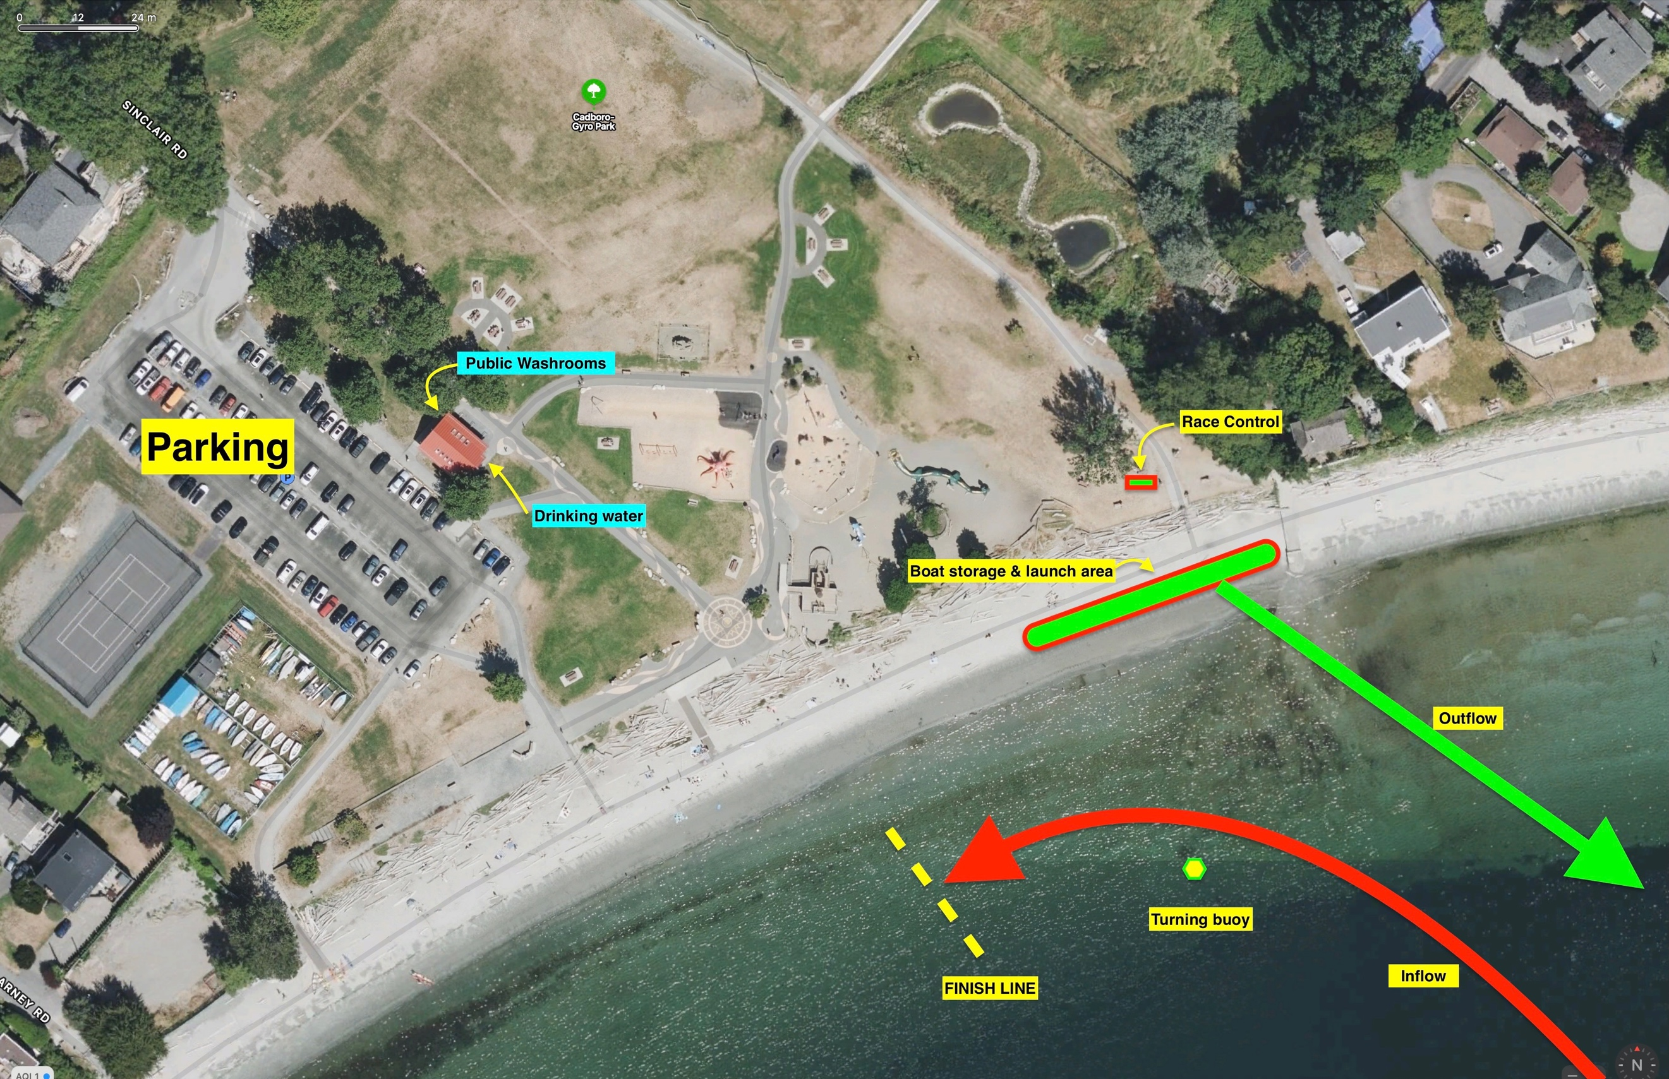

Cadborosaurus Coastal Regatta
Tides & Currents for April 10, 2022

Sunrise: 5:32am
Sunset: 6:58pm

2022-04-10 (Sunday)
Time | Height
PDT | (m) | (ft)
02:58 | 2.8 | 9.2
18:02 | 1.0 | 3.3

Date | Hour
PDT | 07 | 08 | 09 | 10 | 11 | 12 | 13 | 14 | 15 | 16
 | 2.5 | 2.4 | 2.3 | 2.2 | 2.1 | 2.0 | 1.8 | 1.6 | 1.4 | 1.2

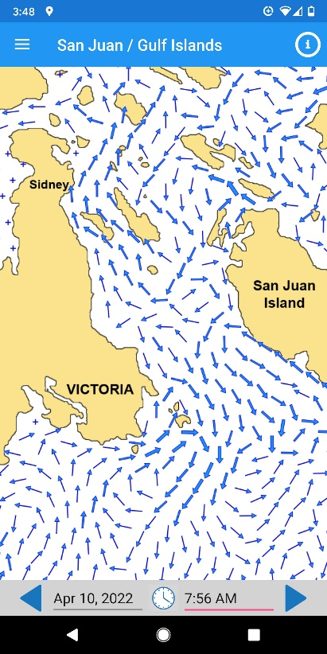 | 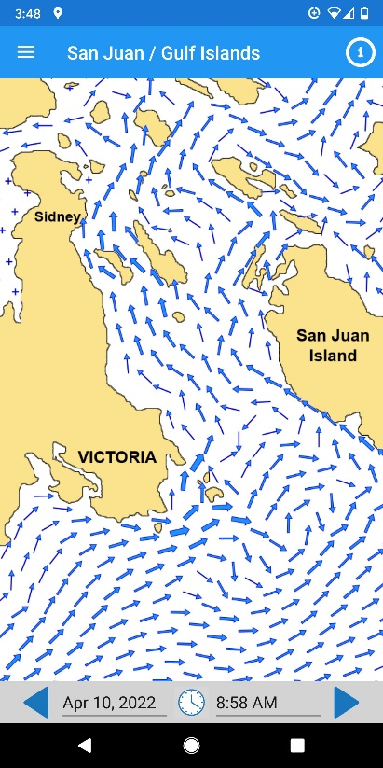 | 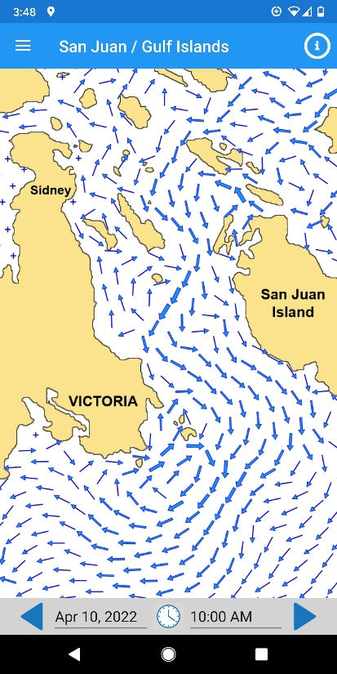
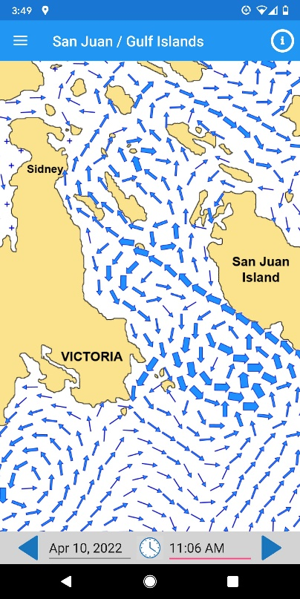 | 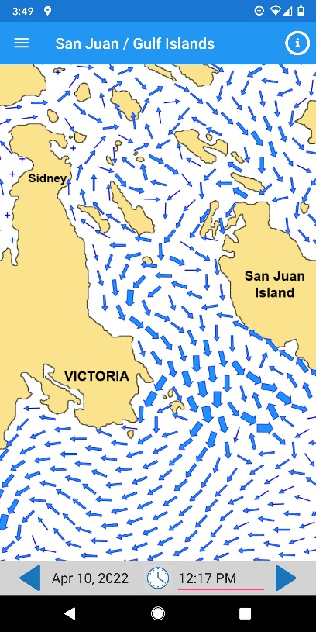 | 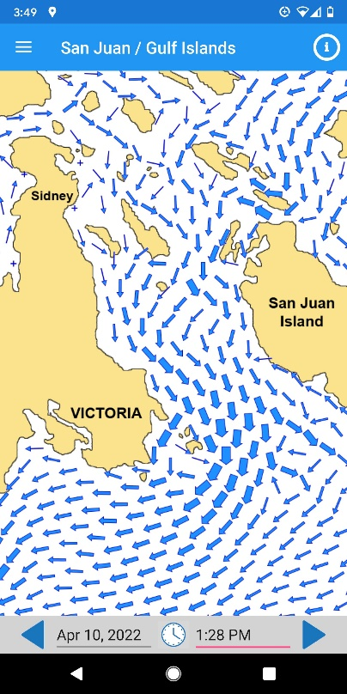
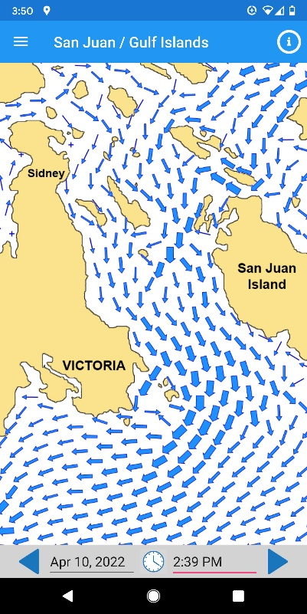 | 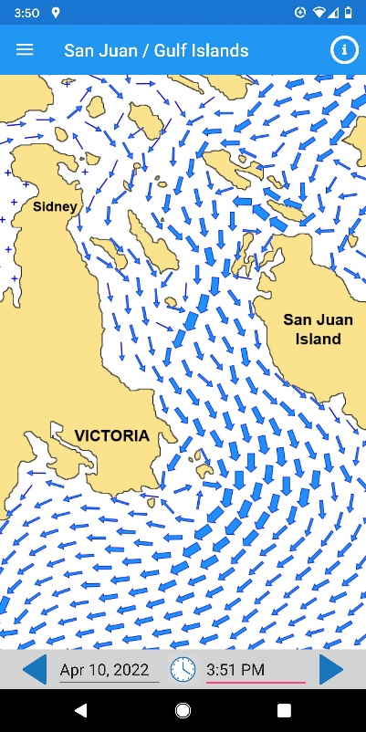 | 