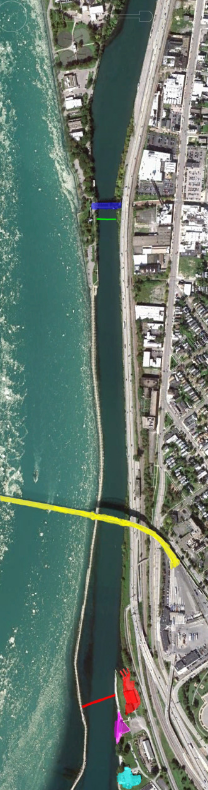

John Bennett Regatta

Course Map

KEY:

… Red: West Side/ Launching docks

... Magenta: Fontana Boathouse/ Docking

… Blue: Ferry St. Bridge

… Yellow: Peace Bridge

… Turquoise: Yacht Club

… Green Line: Start

… Red Line: Finish

Good Luck!

Traffic Flow:

1. Launch at the West Side docks when your race is called
2. Proceed to the start sticking to the city side of the course for Time Trials. Finals only you cross
3. Continue rowing past Ferry St, Bridge and fall into racing order behind other boats.
4. Follow the official’s orders for getting into racing order.
5. When racing stick to your lane and the river side of the course to avoid oncoming traffic.
6. After finishing continue past the yacht club where officials will let you know where to turn.
7. When it is your turn, dock at the Fontana Boathouse.